

Content Lists Available at Directory of Open Access Journals (DOAJ)
Al-Falah: Journal of Islamic Economics
Journal Homepage: http://www.journal.iaincurup.ac.id/index.php/alfalah
DOI: https://dx.doi.org/10.29240/alfalah.v8i2.8210

The Influence of Islamic Insurance And Islamic Banks On Indonesia's Economic Growth For The Period 2016-2022
Maryam Batubara^{1*}, Sakti Andiyanto²
^{1,2} Universitas Islam Negri Sumatera Utara, Indonesia
*Corresponding Author. E-mail: maryam.batubara@uinsu.ac.id
ARTICLE INFO |  | ABSTRACT  Purpose: The goal of this research is to discover and assess the impact of Islamic insurance and Islamic banks on economic growth. Examining the Impact of Islamic Insurance on Indonesian Economic Growth and the Impact of Islamic Banks on Indonesian Economic Growth. In this scenario, the research was carried out between 2016 and 2022.  Design/Method/Approach: This is descriptive study using a quantitative research technique. With secondary data sources obtained from financial reports published by the Financial Services Authority (OJK), namely IKNB Sariah which contains financial reports for all sharia insurance and banking statistics for the 2016-2022 period. In this research, the population and sample are all monthly financial reports of Indonesian Sharia Insurance and sharia banking in quarterly form for the period 2016-2022. Economic growth is the research's dependent variable. Meanwhile, Sharia Insurance and Sharia Banking are the independent factors. This study's data will be examined utilizing research instrument testing, traditional assumption tests, multiple regression tests, and hypothesis tests.  Findings: According to the partial test results, the Islamic insurance variable has no significant influence on economic growth in Indonesia for the 2016-2022 periods; however the Islamic banking variable has a positive and substantial effect on economic growth in Indonesia for the 2016-2022 periods. While the test findings between Islamic Insurance and Islamic Banks on Indonesian Economic Growth, the two data evaluated in this study combined have a substantial impact on economic growth.  Originality/Value: This study adds value by examining the impact of Islamic Insurance and Islamic Banks to annual economic development in Indonesia from 2016 to 2022. Also as a fundamental study to see the opportunities and weaknesses of Islamic Insurance and Syraiah Banking in Indonesia, for Indonesia's economic growth.
Article History:
Received: 2023-10-08
Revised: 2023-10-14
Accepted: 2023-11-12

Keywords:
Insurance, Banks;
Economic;
Growth.

Paper Type:
Research Paper

INTRODUCTION
Islamic economy is growing fast and has been for some time. Numerous Islamic economic industry organizations, including Islamic banks, Islamic non-banks, and halal businesses including halal tourism, halal food, travel, and other halal sectors, assist the expansion of the Islamic economy. This demonstrates the growing tendency toward sharia economics. Like the following table's Average Growth of Global Sharia Financial Industry Assets for the Period of 2016–2021.
Graph 1. Average Asset Growth of the Global Islamic Finance Industry 2016-2021.
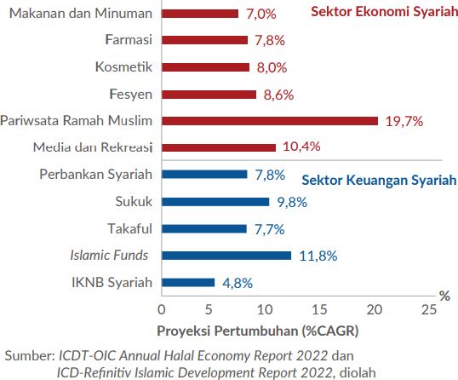
A number of inhibiting factors need to be watched out for regarding the development of global Islamic finance going forward. Several factors such as the continuation of global inflationary pressures that will drive the trend of monetary tightening and rising interest rates, as well as fiscal normalization need attention because they can affect the development of Islamic finance, especially Islamic banking and sukuk issuance. In addition, the takaful sector needs to be encouraged towards stronger innovation in order to run competitively amidst intense competition with conventional insurance and increasing public health risks.
The expansion of Indonesia's Sharia Non-Bank Financial Industry (IKNB Syariah), one of which is Sharia Insurance, which is currently also beginning to grow in Indonesia, and many insurance companies are beginning to see this opportunity, plays a significant role in the country's sharia industry and economic growth.
Indonesia is one of the nations with the world's largest Muslim populations. At least 234 million Indonesians, or 87 percent of the overall population, are Muslims. This has garnered the full attention of many observers, particularly those who have studied the topic of Sharia.
The nation with the largest Muslim population in the world is Indonesia with the start of PT. Syarikat Takafuln Indonesia (Takaful Indonesia) in 1994, Indonesia began to do out Sharia insurance. At that time divided the 2 companies, PT Asuransi Takaful Umum and PT Asuransi Takaful Keluarga, both focused upon offering sharia general insurance and sharia life insurance, respectively. 20 sharia life insurance firms & 37 Islamic insurance companies existed as of 2010. In 2015, 53 companies increased in number, among them are 24 sharia life insurance businesses.
Along with the times, Islamic insurance in Indonesia has the potential to expand in tandem with the expansion of the Islamic financial system. The development of Islamic insurance in Indonesia will be highly influenced by public attitudes and behavior regarding the presence of Islamic insurance, as well as circumstances that encourage the existence of insurance and public awareness. Islamic insurance has always been a part of the global Islamic financial business. Indonesia, being one of the world's most populous countries with a Muslim majority, is expected to expand at a rate of 15-20% every year.
Islamic banking in Indonesia is also expanding in the Indonesian banking sector as an alternate option for the public to utilize financial products that adhere to Sharia principles in their implementation. Of sure, it helps to boost Indonesia's economic growth.
Islamic banking is inextricably linked to the Indonesian banking sector in general. The Islamic banking system began to be recognized in 1992 with the issuance of Law No. 7 of 1992 which allowed Profit sharing is a form to run bank operations. In the same year, Bank Muamalat Indonesia (BMI) emerged Indonesia's first sharia bank.
Islamic banking's significance in supporting the national economy has grown in tandem with its relatively quick expansion during the previous 10 years from 2004. Islamic banks can perform the intermediation role and real sector finance optimally. With the introduction of the policy of opening sharia services (office channeling) in 2006, there was a large rise in the Islamic banking office network, which played an essential role in supporting the intermediate function of Islamic banking.
Based on the background explanation provided above, the goal of the discussion in this research will be to examine the impact of Islamic insurance and Islamic banking on economic growth in Indonesia. By processing data acquired from the OJK (Financial Services Authority) media and the Central Statistics Agency (BPS).

RESEARCH METHOD
This study is of the kind is descriptive research; A quantitative research technique is applied. Secondary data derived from financial reports financial services authority (OJK) publication, namely IKNB Syariah which contains the financial statements of all Islamic insurance and Islamic banking statistics for the period 2016-2022. Using a library research approach. In this study, the population and sample are all monthly financial reports of Indonesian Islamic Insurance and monthly financial reports of Islamic banking in the form of quarters from the 2016-2022 period. In research, the variable that is dependent is economic growth. While the independent variables are Islamic Insurance and Islamic Banking. The data collected in this study will be tested using the research instrument test, classical assumption test, multiple regression test, and hypothesis testing.
RESULT AND DISCUSSION
Overview o,f Sharia Insurance
Data in Sharia insurance was used from financial services authority publications. assets from 2016 to 2022, which is the independent variable in this research analysis. The information is a time series that is collected periodically. The entire value of Islamic insurance assets from 2016 to 2022 is presented here in quarterly form, to obtain the value of assets in quarterly form:
Graph 2. Islamic Insurance Assets Quarterly Report 2016-2022 In Billion
Source: Financial Services Authority, 2023 (Processed Results)
The graph above shows the amount of Islamic insurance assets from 2016-2022, which is divided into four parts per year, namely first, second, third, and fourth quarters. Data obtained from the average value of assets per quarter of Islamic insurance. Quarter I from February, March, and January. 2nd quarter from May, June, and April. 3nd quarter data from August, September, and July. While the fourth fourth of data from November, December, and October.
Overview of Islamic Banks
Aggregate data information on Islamic banking assets from 2016 to 2022 accessed from Bank Indonesia is the study's second independent variable. The information is a time series collected periodically. The entire value of Islamic insurance assets from 2016 to 2022 is presented here:
Chart 3. Islamic Bank Assets Quarterly Report 2016-2022 in Billion
Source: Financial Services Authority, 2023 (Processed Results)
The graph above shows the amount of Islamic bank assets from 2016-2022, which is divided into four parts per year, namely I, II, III, and IV are the four quarters.. Data obtained from the average value of assets per quarter of Islamic insurance. Quarter I from February, March, and January. Quarter II from May, June, and April Quarter III data from August, September, and July. While the fourth quarter of data from November, December, and October.
Overview of Indonesia's Economic Growth
Economic growth data from 2017 to 2019 received from the Financial Services Authority is the dependent variable in this study. The information is a time series that is collected periodically. The economic increase from 2017 to 2019 is explained here:
Graph 4. Economic Growth quarterly report 2016-2022 in Trillion
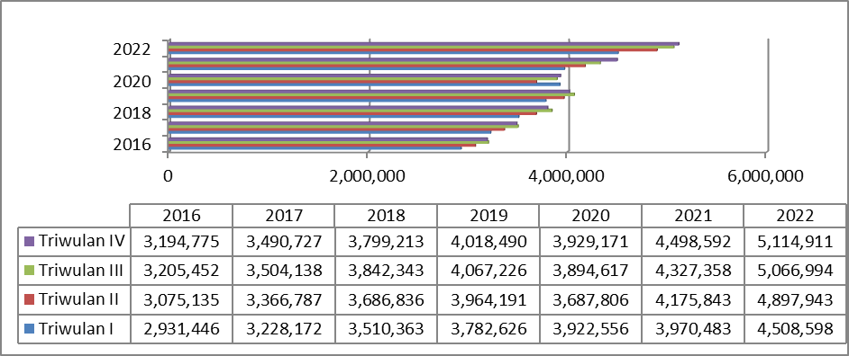
Source: Financial Services Authority, 2023 (Processed Results)
Clasical Assumption Test
The traditional assumption test that researchers offer looks like this:
Normality Test
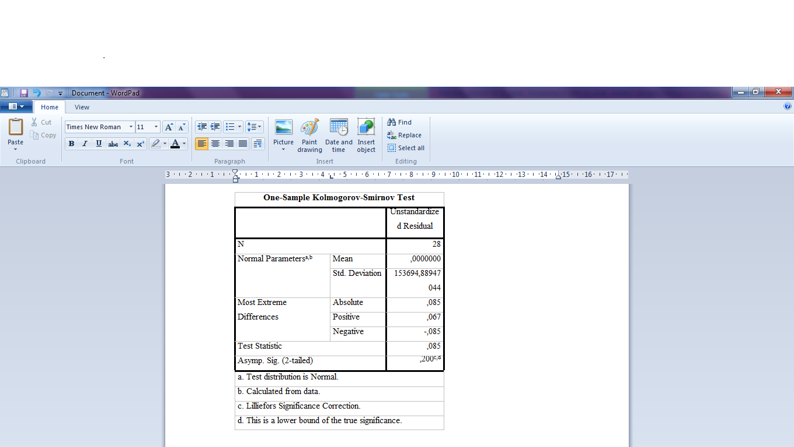
Determine if the independent variables pass the test for the normalcy assumption, dependent variables, or all regression models are normally distributed or not. A rough normal distribution defines an efficient regression model. A test table was used in this study for routine testing.

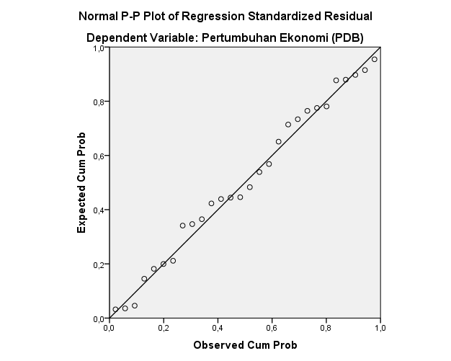
It is known that the significant findings of the variable test above reveal 0.200> 0.05 based on the normality test. As a result, it may be said that the residual value has a normal distribution. pain

The regression model is consistent with the norm criteria if the data is evenly distributed circumnavigating the diagonal, in the diagonal line's direction, and resembles a regular distribution. The normal probability plot in the figure above reveals that the points in the plot all point in the same direction, namely the diagonal line, indicating the residuals have a known normal distribution.
Hesteroscedasticity Test Results
The goal of this heteroscedasticity test is to assess whether there is a variance disparity between the residuals of different regression model observationsif there is just one observation and the subsequent observation stays constant, the phenomenon is referred to as homoscedasticity; if it fluctuates, it is referred to as heteroscedasticity. The results of the variance test are given below:
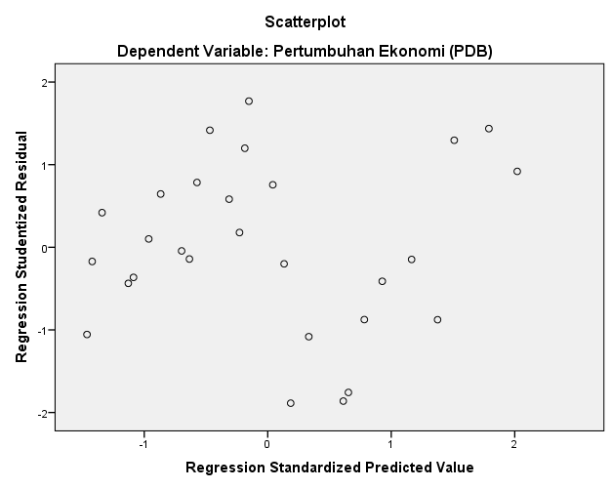
As shown above, the model is free from the assumption of heteroscedasticity as it has no pattern and spread visible in the distribution of dots in the plot.
Multicolonierity Test
If the regression model detects a strong or perfect correlation between the independent variables, it will pass the multicollinearity test. The tolerance value or Variance Inflation Factor (VIF) can be used to determine if the regression model has multicollinearity. Testing the data revealed the following results:
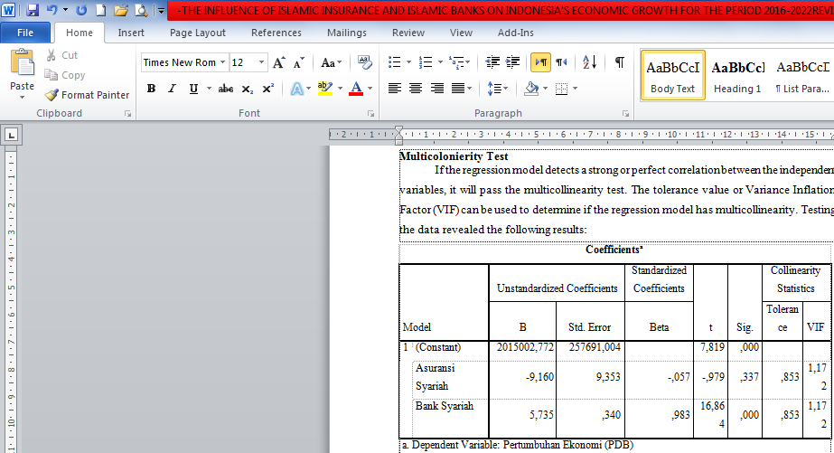

The total tolerance value for Islamic insurance and Islamic banks is 0.853, according to the test results using the Variance Inflation Factor (VIF) in the table above.
Given that all variables have a tolerance value greater than > 0.10, Islamic insurance has a VIF score of 1.172. In other words, the multiple linear regression model is free from multicollinearity and can be utilized in research. So, it can be said that in the regression model between independent variables there is no correlation.
Autocorrelation Test
In the linear regression model, the autocorrelation test looks for a relationship between confounding errors in period t and errors in period t-1 (prior). If autocorrelation occurs, the equation is not suitable for use as a predictive tool and is not considered a viable regression equation. The autocorrelation test findings are as follows:
Model Summary^{b}
Model | R | R Square | Adjusted R Square | Std. Error of the Estimate | Durbin-Watson
1 | ,963ª | ,927 | ,922 | 159724,41446 | ,677
a. Predictors: (Constant), Bank Syariah, Asuransi Syariah
b. Dependent Variable: Pertumbuhan Ekonomi (PDB)

The SPSS output findings are shown the data in the table, and indicate that the Durbin- Watson value is 0.677 or the Durbin-Watson (D-W) value is between -2 and +2, indicating that autocorrelation does not affect the test data. The equation hypothesis for multiple linear regression analysis can thus be tested for the study.
Hypothesis Testing
The results of testing the researcher's hypothesis are presented as follows.
Multiple Linear Regression Analysis
The purpose of this multiple liner Regression analysis is used to identify the impact of depending upon the independent variable. The following are the results of the SPSS output:
Coefficientsª
Model |  | Unstandardized Coefficients |  | Standardized Coefficients | T | Sig.
 |  | B | Std. Error | Beta | T | Sig.
1 | (Constant) | 2015002,772 | 257691,004 |  | 7,819 | ,000
1 | Asuransi Syariah | -9,160 | 9,353 | -,057 | -,979 | ,337
1 | Bank Syariah | 5,735 | ,340 | ,983 | 16,864 | ,000
a. Dependent Variable: Pertumbuhan Ekonomi (PDB)

Based on the table above,it is evident that:
- The value of the constant is 2015002.772., as a result of which if the Islamic insurance and Islamic banking variables are worth 0, economic growth will be worth 2015002.772.
- The coefficient of Islamic insurance is -9.160, as a result of which if the Islamic insurance variable increases by 1 billion, then economic growth will increase by 9.160 assuming other independent variables are constant.
- Islamic banking's coefficient is 5.735., i.e., if the Islamic banking variable rises by 1 billion, economic growth will decline by 5.735, Considering the other independent variables as being constant.
As a result, the following multiple regression equation may be constructed::
Y= α + β1.X1+β2.X2+e
Y= 2015002,772+ (-9,160) . Sharia Insurance+ 5,735. Islamic Bank+ 257691.004
Test Coefficient of Determination (R2)
The R2 function describes the findings of the independent variable's capacity to explain the dependent variable. The R2 (R- Square) test results are as follows.:

Model Summary
Model | R | R Square | Adjusted R Square | Std. Error of the Estimate
1 | ,963ª | ,927 | ,922 | 159724,41446
a. Predictors: (Constant), Bank Syariah, Asuransi Syariah

The R2 (R-Square) Test may then be validated, and the number 0.927 can be explained, meaning that 92.7% of Islamic banking and sharia insurance are two independent variables that can explain the dependent variable of economic growth. Other variables thought to impact the dependent variable (Economic Growth) can be explained by the remaining 7.3%.
Partial Test (T-Test)
The purpose of a partial test (t-test) is to ascertain the partial (individual). The relationship between the independent and dependent variables. Here are the test results:
Coefficientsª
Model |  | Unstandardized Coefficients |  | Standardized Coefficients | T | Sig.
 |  | B | Std. Error | Beta | T | Sig.
1 | (Constant) | 2015002,772 | 257691,004 |  | 7,819 | ,000
1 | Asuransi Syariah | -9,160 | 9,353 | -,057 | -,979 | ,337
1 | Bank Syariah | 5,735 | ,340 | ,983 | 16,864 | ,000
a. Dependent Variable: Pertumbuhan Ekonomi (PDB)

For the Islamic insurance variable, a t value of -0.979 and a sig. value of 0.337 were generated based on the incomplete test data in the table above The t and sig values of 0.337> (0.05) get the expected results. Then, Ho1 is approved but Ha1 is refused. In other words, during the years 2016 to 2022, the Islamic insurance variable has no impact on Indonesia's economic development.
The incomplete test results on the Islamic banking variable yielded a t value of 16.864 and a sig. value of 0.00. the outcome with a sig value of 0.00 (0.05). After that, Ho2 is refused whereas Ha2 is approved. This means that the Islamic banking variable has a favorable and substantial impact on Indonesia's economic growth for the 2017-2019 period.
Simultaneous Test (F-test)
Simultaneous Test (Test-‘f’) aims’ to see the effect of each independent variable simultaneously (together) on the dependent variable. The test results that have been carried out are as follows:
ANOVAª
Model |  | Sum of Squares | Df | Mean Square | F | Sig.
1 | Regression | 8153239058870,100 | 2 | 4076619529435,050 | 159,793 | ,000^{b}
1 | Residual | 637797214331,902 | 25 | 25511888573,276
1 | Total | 8791036273202,001 | 27
a. Dependent Variable: Pertumbuhan Ekonomi (PDB)
b. Predictors: (Constant), Bank Syariah, Asuransi Syariah

From the simultaneous test results (F-test) in the table, it shows that the F value is 159.793 with a sig value. 0,00. The significant result of F 0.000 < α (0.05). Then Ha3 is accepted and H03 is rejected, so it can be concluded that the variables of Islamic insurance and Islamic banking simultaneously and have a major effect on the economic expansion of Indonesia from 2016 to 2022.
The Effect of Islamic Insurance on Economic Growth
That the Indonesian economic development variable is known not to effect the sharia insurance variable. based on the T test, which utilizes a partial data test for 2016-2022. This means that investment posts made by Islamic insurance do not give a positive signal for economic growth rate. Therefore, This contradicts the assumption that investment spending gives a favorable indication for future corporate growth so that it can increase stock prices as an indicator in assessing the company.
According to study done by Budi, Yasa, and Wardhana (2013), Islamic insurance has no influence on economic growth. Meanwhile, this contradicts research conducted by (Mainata and Pratiwi, 2019) entitled The Effect of Sharia Insurance Growth on Economic Growth in Indonesia, which employs quantitative methods and finds that the growth of sharia insurance has an impact on Indonesia's economic growth, specifically GDP.
In Khairina's research (2020) which discusses the growth of Sharia Insurance Assets, during 2016 to 2020, it was found that the Composite Stock Price Index (IHSG) had a large and detrimental influence on the expansion of sharia insurance business assets. The study assumes that this is because the IHSG has increased, causing the sharia insurance business to spend more money. In addition, according to IKNB Syariah OJK statistics (2020), the investment component of the sharia insurance business is the largest in sharia equities, reaching IDR 13.09 trillion or 35.05 percent of the entire investment. IHSG's detrimental and notable effect on the asset growth of the Shariah insurance industry resulted from this.
The Effect of Islamic Banking on Economic Growth
The partial test or T test findings of the Islamic Bank variable on the Indonesian Economic Growth variable for the 2016-2022 period have a positive and significant influence. Consistent with the Harrod-Domar idea. During the same time period, the Harrod-Domar hypothesis was developed separately (individually). Both agree that investment is critical to economic growth since it increases the stock of capital goods, allowing for a rise in production. Domestic funds for investment are derived from the output share (saved national income).
Hence the findings of this study are consistent with those results of Abduh and Omar's research (2012) analyzing utilizing the ARDL approach, the long-term and short-term relationships between Islamic banks and economic growth in Indonesia. The results showed a two-way relationship and a significant relationship between Islamic banking financing and economic growth in the long and short term. This means that Islamic banking shows effective performance as an intermediary institution in channeling financing. Kassim (2015) used the ARDL technique to evaluate how Islamic money affected macroeconomic indices. The findings demonstrated that Islamic finance already plays a significant role in the economic sector by successfully collecting and directing funds for investments. By effectively handling intermediate tasks including collecting and directing funds to investment activities, Islamic banking may support the real estate market.
Meanwhile, in research by Nabilah and Dahruji (2022) it is stated that sharia banking has a positive effect on Indonesia's economic growth. Customer interest in sharia-based banking is increased in part through marketing and outreach efforts, this and the development of sharia banking as Indonesia's economic engine cannot be separated. Aiming to teach and popularize sharia banking products as well as sharia economic activities and lifestyles, Bank Indonesia is one of the organizations that routinely hosts sharia economic weeks each year in many regions in Indonesia.
The Effect of Islamic Insurance and Islamic Banks on Economic Growth
Considering the results of the tests performed above, on the research data utilized in this study, it is discovered that all traditional assumption tests, including the normality test, heteroscedasticity test, multicolonierity test, and autocorrelation test, have been met.
When viewed from R2 is the coefficient of determination resulting from This research test yielded 92.7% outcomes, the two data tested in this study together have a tremendous impact on economic growth. While factors unrelated to the model have an impact on the remaining 7.3%. Other variables outside the model that affect asset growth.
The simultaneous test results for the independent variables of Islamic Insurance and Islamic banking on economic growth show that 0.000 is a significant figure. As the value of the F test is less than 5% ( = 0.05), then sharia insurance and sharia banking have a significant impact on the growth of the Indonesian economy. As a result, the Ha hypothesis can be accepted, this means that Islamic insurance and Islamic banking have a substantial impact on economic growth at the same time.
So, for the 2016-2022 data period, the influence of Islamic Insurance and Islamic Banking on Economic Growth in Indonesia has a favorable distribution and a substantial effect. So in accordance with the theory of economic growth, namely Neo Classic Growth Theory. The focus of the discussion of Neo Classic growth theory is the accumulation of capital stock and its relationship with people's decisions to save or invest.
CONCLUSION
According to the preliminary test findings, Indonesia's economic development from 2016 to 2022 will not be significantly impacted by the Islamic insurance variable, and while Indonesia's economic development from 2017 to 2019 will be positively and significantly impacted by the Islamic banking variable. While the coefficient of determination (R2) between Islamic Insurance and Islamic Banks on Indonesia's Economic Growth Priode 2016-2022, the two variables examined in this study, when combined, significantly affect economic growth.■

REFERENCES
Amron, Usman, and Ali, Buying decision in the marketing of Sharia life insurance (evidence from Indonesia), ‘Keputusan Membeli Dalam Pemasaran Asuransi Jiwa Syariah (Bukti Dari Indonesia’, Journal Emerald Insight, Unit 07, 2010, 1–5 <file:///D:/File Sekolah Bunda/amron2018.pdf>
El Ayyubi, Salahuddin, Lukytawati Anggraeni, and Almira Dyah Mahiswari, ‘Pengaruh Bank Syariah Terhadap Pertumbuhan Ekonomi Di Indonesia’, Al-Muzara’ah, 5.2 (2018), 88–106 <https://doi.org/10.29244/jam.5.2.88-106>
Bank Indonesia, ‘Kajian Ekonomi Dan Keuanagn Syariah 2022 Sinergi Dan Inovasi: Meningkatkan Kontribusi Ekonomi Dan Keuangan Syariah’, 2022, pp. 1–214
Fahriza, Nanda Rizqi, and Iza Hanifuddin, ‘The Influence Demographic Factor on Growth of Sharia Insurance in Indonesia’, AL-HISAB: Jurnal Ekonomi Syariah, 2.1 (2021), 17–39
Al Madani, Nabilah, and Dahruji Dahruji, ‘The Analysis of Influence State Expenditures, Islamic Banking Finance and Foreign Investment (Pma) Economic Growth in Indonesia 2017-2022’, LISAN AL-HAL: Jurnal Pengembangan Pemikiran Dan Kebudayaan, 16.2 (2022), 273–94 <https://doi.org/10.35316/lisanalhal.v16i2.273-294>
Rafsanjani, Haqiqi, and Raditya Sukmana, ‘Pengaruh Perbankan Atas Pertumbuhan Ekonomi : Studi Kasus Bank Konvensional Dan Bank Syariah Di Indonesia’, Jurnal Aplikasi Manajemen (JAM), 12.September (2014), 492–502
Soleha, Arin Ramadhiani, and Iza Hanifuddin, ‘Perbandingan Kontribusi Bruto Asuransi Syariah Sebelum Dan Sesudah Pandemi Covid-19’, Journal of Islamic Economics and Finance Studies, 2.2 (2021), 142 <https://doi.org/10.47700/jiefes.v2i2.3461>
Suryadi, Hilman, ‘Analysis Of The Factors That Influence The Growth Of Sharia Insurance Industry Assets In Indonesia (2016-2020 Period)’, Dinar : Jurnal Ekonomi Dan Keuangan Islam, 8.1 (2021), 1–14 <https://doi.org/10.21107/dinar.v8i1.10732>
Syafrida, Ida, and Indianik Aminah, ‘Faktor Perlambatan Pertumbuhan Bank Syariah Di Indonesia Dan Upaya Penanganannya’, Ekonomi Dan Bisnis, 14.1 (2015), 7–20
Wihastuti, L., ‘Pertumbuhan Ekonomi Indonesia: Determinan Dan Prospeknya’, Jurnal Ekonomi & Studi Pembangunan, 9.1 (2008), 30660
Zubair, Muhammad Kamal, ‘Akselerasi Pertumbuhan Bank Syariah Di Indonesia’, Millah, 8.1 (2008), 1–16 <https://doi.org/10.20885/millah.vol8.iss1.art1>

Kajian Ekonomi dan Keuanagn Syariah 2022 Sinergi Dan Inovasi: Meningkatkan Kontribusi Ekonomi Dan Keuangan Bank Indonesia, pp. 1–214.
Arin Ramadhiani Soleha and Iza Hanifuddin, ‘Perbandingan Kontribusi Bruto Asuransi Syariah Sebelum Dan Sesudah Pandemi Covid-19’, Journal of Islamic Economics and Finance Studies, 2.2 (2021), 142 <https://doi.org/10.47700/jiefes.v2i2.3461>.
Buying decision in the marketing of Sharia life insurance (evidence from Indonesia) Amron, Usman, and Ali, ‘Keputusan Membeli Dalam Pemasaran Asuransi Jiwa Syariah (Bukti Dari Indonesia’, Journal Emerald Insight, Unit 07, 2010, 1–5 <file:///D:/File Sekolah Bunda/amron2018.pdf>.
Nanda Rizqi Fahriza and Iza Hanifuddin, ‘The Influence Demographic Factor on Growth of Sharia Insurance in Indonesia’, AL-HISAB: Jurnal Ekonomi Syariah, 2.1 (2021), 17–39.
Muhammad Kamal Zubair, ‘Akselerasi Pertumbuhan Bank Syariah Di Indonesia’, Millah, 8.1 (2008), 1–16 <https://doi.org/10.20885/millah.vol8.iss1.art1>.
Ida Syafrida and Indianik Aminah, ‘Faktor Perlambatan Pertumbuhan Bank Syariah Di Indonesia Dan Upaya Penanganannya’, Ekonomi Dan Bisnis, 14.1 (2015), 7–20.
L. Wihastuti, ‘PERTUMBUHAN EKONOMI INDONESIA: Determinan Dan Prospeknya’, Jurnal Ekonomi & Studi Pembangunan, 9.1 (2008), 30660.
Hilman Suryadi, ‘Analysis Of The Factors That Influence The Growth Of Sharia Insurance Industry Assets In Indonesia (2016-2020 Period)’, Dinar : Jurnal Ekonomi Dan Keuangan Islam, 8.1 (2021), 1–14 <https://doi.org/10.21107/dinar.v8i1.10732>.
Haqiqi Rafsanjani and Raditya Sukmana, ‘Pengaruh Perbankan Atas Pertumbuhan Ekonomi : Studi Kasus Bank Konvensional Dan Bank Syariah Di Indonesia’, Jurnal Aplikasi Manajemen (JAM), 12.September (2014), 492–502.
Salahuddin El Ayyubi, Lukytawati Anggraeni, and Almira Dyah Mahiswari, ‘Pengaruh Bank Syariah Terhadap Pertumbuhan Ekonomi Di Indonesia’, Al-Muzara’ah, 5.2 (2018), 88–106 <https://doi.org/10.29244/jam.5.2.88-106>.
Nabilah Al Madani and Dahruji Dahruji, ‘The Analysis of Influence State Expenditures, Islamic Banking Finance and Foreign Investment (Pma) Economic Growth in Indonesia 2017-2022’, LISAN AL-HAL: Jurnal Pengembangan Pemikiran Dan Kebudayaan, 16.2 (2022), 273–94 <https://doi.org/10.35316/lisanalhal.v16i2.273-294>.
Rafsanjani and Sukmana.

