TABLE ANALYSIS OF STUDENTS’ WRITING COMPOSITION OF SIMPLE PAST TENSE
NO | Stu-dents’  Initial Name | WRITING COMPOSITION | ERROR ANALYSIS
NO | Stu-dents’  Initial Name | WRITING COMPOSITION | GRAMMAR | PUNCTUATION | SPELLING
 | RAPKD | Holiday Story  The last holiday, I spent the time when my friends on vacation to relative’s house in Malang, approximately 12 hour trip by motorcycle from our home in Solo. On the way there, we saw many beautiful view such as rice fields, mountains, etc. Having arrived at the uncle’s house, we were greeted by our relatives who had not met us for a long time. The next day, we walked around the town of Malang until the sky got dark. Finally we decided to go home at 06.00 pm on that day. On the next day, I forgot that it was the New Year. Suddenly, one of my cousins came and asked me and my friends to celebrate the New Year with his family. When the count and arrived, the sky was dark at once then because so colourfully decorated by fireworks. We prayed together and watched the fireworks lightening the sky that night. Suddenly, the holiday passed quickly. The last New Year’s holiday experience in the city of Malang was so impressed for me. | 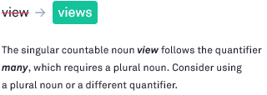 |  | 
 | RA | My Holiday  Last week, my family went to Yogyakarta, we visited many places there. First, we visited Plaosan temple and Green temple was a beautiful temple. We took some photos there. After that we went to Gembira Loka zoo. We saw many kinds of animals there such as tiger, snakes, collection, bird collection, etc. We looked around in that zoo. And also took picture those animal. After from Gembira Loka zoo. We went to Galuh hotel to take a rest. Galuh hotel was a famous hotel in Yogyakarta. The facilities made me comfortable during I stayed there. In the next day, we went to Sadranan beach. Sadranan beach was very beautiful and interesting. I played the white sands, I swam there and I saw some people practiced rock climbing there. Sadranan each was in Gunung Kidul. About 2 hours from the center of Yogyakarta. I played for some hours until I felt tired and decided to go back to our car. Then we felt hungry, so we went to a chinnese restaurant. After we finished our dinner. We decided to go home. That was a good moment because I could spend my time with my family. We really enjoyed it. | 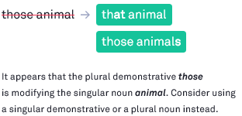 | 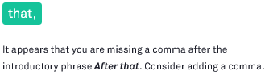 | 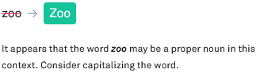  
 | RDP | The Story of Holiday at Home  The last holiday, I chose to spend the time at home just because I wanted to have a lot of time hangout with my family at home. The first day, I did some activities that I rarely do in school days. I started thes activities with jogging in the morning, then playing games on the playstation, and playing guitar until 10.00 am. After that I took a bath, and continued playing the playstation games again until 12.00. Midday prayer time Dzuhur came so I must pray and then followed by lunch. After midday prayers and lunch, I and all members of the family gathered in the living room to watch TV together while chatting. |  |   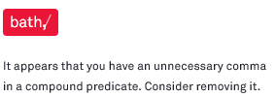 | 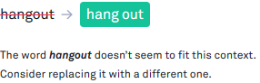  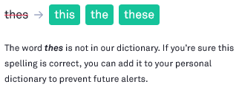  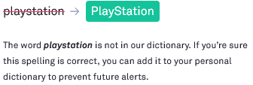
 | LWL | My Holiday  The holiday yesterday I didn’t go traveled and I just holiday in the house. But I was happy. And I will tell in here. The holiday for a week yesterday I had a lot of time and I was confused what should I do to filled my holiday so after thinking, I decided to read a novel. And it happened to my sister had a new novel wich titled “Assalamualaikum Calon Imam” creation of Madani seen from the title I guess it was interesting. So I borrowed that novel. The novel was fairly thick. So I could fill my free time to read it. And as alleged I ever. The novel is very interesting and contained many lessen in the story. From at 9 am. I had fun with the novel until I didn’t realized, time for pray Dzuhur was arrived. Finally, I decided for prayer first. And after I prayed, I didin’t patient to continue the story in the novel, because the story of the novel very made me curious. I finished read novel for two days. And I think the novel was very recommended for young people specially for their problem about love. This is my activity when holiday yesterday. | 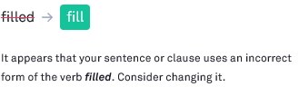  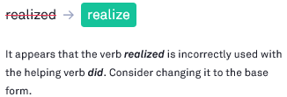  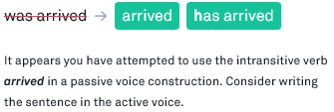  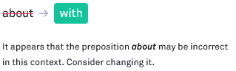  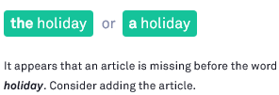 |  |   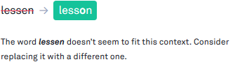  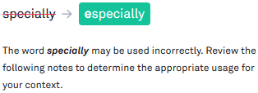
 | EWN | Vacation to the Beach Klayar  On Sunday, precisely at 07.00 am, My family and I vocationed to Klayar Beach. Before we left for the beach KLayar, I prepare food and drinks for us to enjoy there. While my family preparing the vehicle we will use. After everything is ready, we immediately depart to the beach Klayar. During the journey, I was amazed by it’s natural beauty. It’s winding rood is like a wave. It’s rice fields are neatly lined up, and the atmosphere of the mountains is very beautiful. It turns out so great, the gift God has given to us all. Looking for a shady place, that day the weather was hot enough, so we had to find a comfortable place to rest. After getting a suitable place, my brother and I immediately rushed to the beach. Suddenly I heard the voice of someone asking for help. “Please…please…!”. It turns out the voice is my brother voice. I saw the face of my brother was so pale, she was afraid to down. After that incident, my parents asked us to stop swimming and immediately clean our bodies full of sand. Before we go home, do not forget we enjoy the food and drinks. We have prepared from home. After all they feel satisfied in playing. We decided to go home soon. | 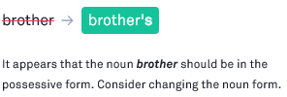 |  | 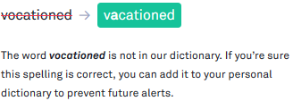  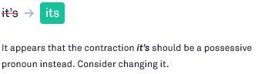
 | TSD | My Holiday  Last 17 December 2017, I went to Sarangan and Gedungombo with my big family. I went to Sangiran for education with my nephew, my niece, my brother. They were elementary school. I disappointed because Gedungombo was close, but it’s ok. I just at in there. My big family and I ate fish and drink a coconut. At 2 pm I went to home but before I went to home, I went to Lembah Gunung Madu in Simo Boyolali arrived at 5 pm. In Saturday 6 January 2018, I went with my niece by motorcycle to Kopeng in Pinus forest or treetop. I went to Kopeng at 8 am. In there the air was very fresh, I enjoyed in there. In Kopeng I just hunting a picture and ate in treetop. In there the air was very fresh in my think. I went to home at 2 pm. The rain came at the moment. I waited the rain until calmed down. I went to home at 3 pm to arrived and the rain came, but it’s ok, I ‘m very happy for that day. Because I liked that place, and last every went to Magelang city in my grandpa, I always to ask my dad to exceed Kopeng. Because the air was very fresh. | 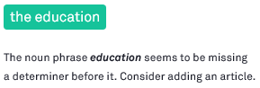  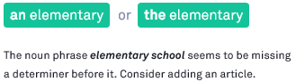    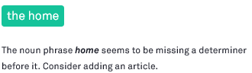    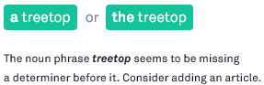  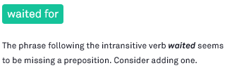  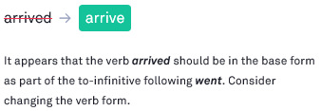
 | ADP | This Is My Adventure the Beach  last week, I and my friend’s going to Jogja by car. I plan to camp in Gunung Kidul Jogja. Before going to the beach, I went to star hill. I went to dinner while enjoying the beautiful scenery. After that I continue the journey to the beach. And than, I and my friend’s got to Indrayanti beach at 10.00 pm. I built a beachside campsite. It was getting darker and colder. So we made a bonfire. I and my friend’s played guitar and sang all night. The weather was so bright it made us happy to be outside camp. The next day, I enjoying the beach weather in the morning. But I and my friend’s disappointed because can not see the sun rise. After I and my friend’s having breakfast and continued play water on the beach. the time showed 1 pm. It was time to us to go back from the beach. We started packing to go home. I hoped it would be held again next time. We enjoyed our night and it was a great fun. | 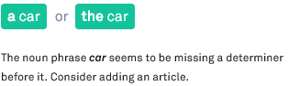    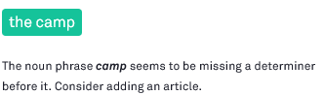  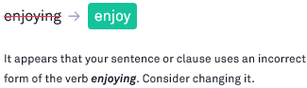 |  | 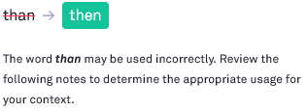  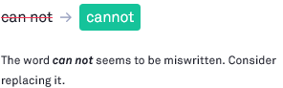  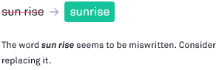
 | ASW | My Holiday  A few months ago I spent vacation time with my family with vacation to Pacitan, approximately 3 hour trip by bus. We leave from home at 08.00. Around at 11.00 we have arrived at the first destination of the cave Tabuhan. Once satisfied to explore and she the cave Tabuhan. We went on the 2nd trip in cave Gong. On the way to cave Gong we took time for lunch. Around at 14.00, we arrived in our second destination. We got off the bus and went back the explore the cave Gong. Late afternoon we continued our last tour on the beach of the Teleng Ria. On the beach we can not just swim the beach or play water and sand. We also took the time buy souvenir. Around 1t 16.30 we decided to go back home. Around 20.00 we get home safely, then we break. | 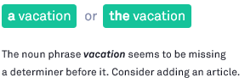  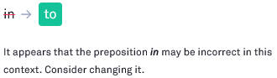  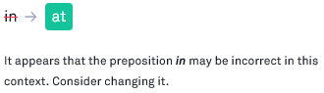  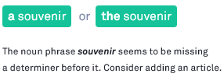 |      | 
 | IAA | My Special Holiday  On my holiday last Sunday. i went to Jepara with my Club for having vacation in the anniversary of Corola Dx Club. There are 15 Lancer Cars in this tour. This Vacation was very fun. We drived our car together. We needed 6 hours to arrived in Jepara. We went to Jepara at the 12 in the midninght. Then we arrived at 05.00 in the morning. We took a picture together when we arrived. After we came for the anniversary of Corola Dx Club. We went to Bandengan Beach. It was chosen as the second destonation of our tour. In Bandengan beach, we swam and played Banana boat. It was very enjoy. After that, we had to lunch together. We went to home at 1 o’clock in the afternoon, but when we arrived in Semarang, we are invited by SL Owner Semarang for had dinner. Finally, we went to home at the 8 o’clock in the evening. Then we arrived in Boyolali in the middle of the night. It was a best holiday. | 
 | YAS | My Holiday in December 2017  I want yesterday on vocation to Jogja. This time chose to ride the train, because I was on holiday alone with my friend called Mieke. Approximately two hours drive to the station, the most enjoyable Jogja holiday on foot, the first destination to Vredenbug fortress. Arriving at the Vredenbug, honestly we do not really understand what is in it, because we just hunting photos. The next destination to the National Museum of Jogja, because travel pretty far we ride the car online. Yesterday before going we’ve been looking for know about Jogja National Museum and events that are going on. And sure enough there is an art event called “Bienalle”. a lot of artwork that is an display there. Besides the committee invites several creators of the art, on of them “Farid Steve” – Filosofi Kopi”. After the event is over and have a happy photo, we go back to the station and go home. My short vocation. | 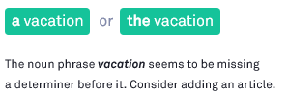  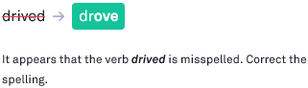  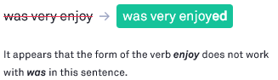    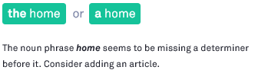   |  | 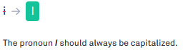  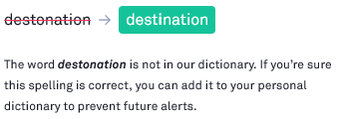
 | OIS | New Year Eve  Last night a new year eve. My frineds and I planned to go to watch music concert in Boyolali city. We planned it since some days before. this new year we did not have any celebration in our home town. Therefore, we wanted to go to city. In the Boyolali city we could not only watch music concert but also fire work. We informed our friend to be together before going there. After we were around fifteen of us, then we prepare to go together. When we just wanted to leave for Boyolali, suddenly the rain fell heavily. It was really heavy rain night along, some of them still wanted to continue our plan, but some other did not agree with. Finally we decided not go there. We had an indoor activity like chating, joking, singing, and so on. Althought our plan was unworkable, but we were happy together. |   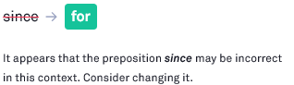  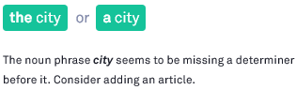  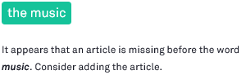   | 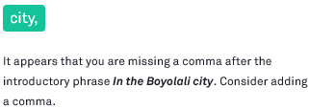   | 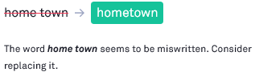  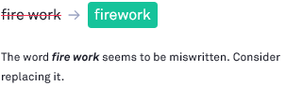  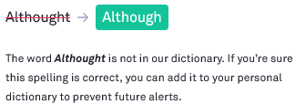  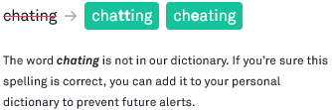
 | LAW | My Holiday  Last week I went to Parangtritis. I went to Parangtritis beach with my family. We went to Parangtritis by car. We started our trip to Parangtritis at six o’clock in the morning. Parangtritis beach was located in the south of Jogjakarta city. After three hour rode my car, my family and I arrived at the beach. Parangtritis was a beautiful beach. It was holiday, so many people came to Parangtritis to spent their time. I was enjoyed the beach. | 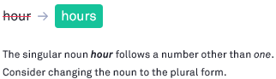  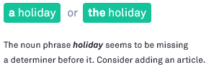  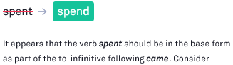  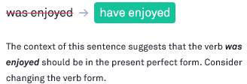
 | DN | My Holiday  Last holiday in new year, my family and I went to “Batu Unite Festival”. This festival located in Baturetno City. This festival to celebrate new year. We saw some traders in there. My brother bought a rainbow ice. After that, we walked beside the street. We saw some reptile from “Pecinta Reptil Pacitan” Community. After that, my family and I went to the home. My mother bought a fried banana to me, but I didn’t like it. So I bought a cake with my father. | 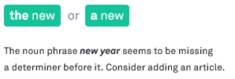  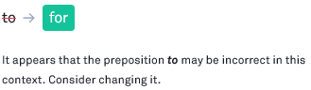
 | RA | My Holiday  Saturday ago me and my friend play in Jogja with my friend named Fitri. We go to Jogja riding a motorcycle. Until in Jogja I met with Fitri. In his house we chatted jokingly. We have not met because of the business of each. After that, we went to the tourist spot which become a favourite place in Jogja, Malioboro. There we photograph photos and walk along malioboro road to enjoy and see the Malioboro crowd. | 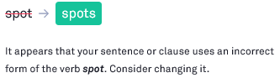  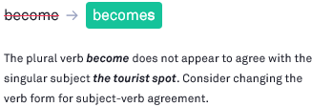 |    | 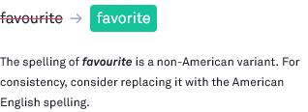  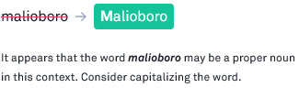
 | MRR | Holiday  long far away My friend and I planned to travel for only refreshing. Let me not saturated. From some the suggestions we decided to travel to the beach in Gunung Kidul. When the day of departure, we were a deal next together at 07.00 o’clock the at 7.15 am we have done met together. Until beach we break a little moment and ate food stock, and after that we played in the beach, we decided to went home soon. |   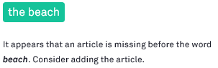  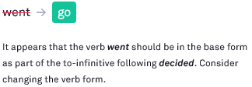 |   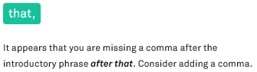
 | AMI | My Last Holiday  I went to Pacitan last month with my family boyfriend. We went to Pacitan by car. On the day we walked to the Goa Gong and Klayar beach, and we took a lot of photos for dinner we were in the Tito meatballs Wonogiri, and ate very tasty meatballs. On the night day the weather was very bad. We had a great time but we have little problems, the time was very short. | 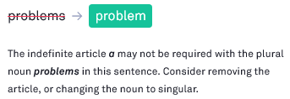 |    | 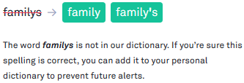
 | BW | My Holiday  My friends and I had a plan. We would go to Bandungan together, because we need holiday. We talked about it via whatsapp messenger. Finally, we found out free day to went holiday. At 14th January 2018 we did that plan. We left Solo at 9 AM. We used google maps to arrived at the Umbul Sidomukti. But the google maps was error, we lost in unknown area. We asked to local people, where we had to go. After that we knew the way. Finally we arrived at Umbul Sidomukti at 1 PM. | 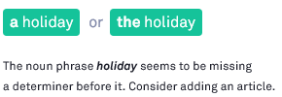  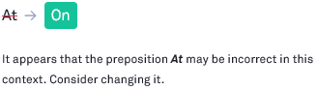  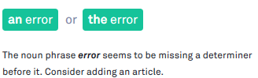  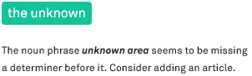   |        | 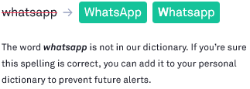
 | AER | My Freeday  Today was my day off. I woke up in this morning on purpose and today I wake up at 2 am in the morning. And I immediately took a bath and rushed to Pacitan with my sister. On a very quiet street and dark rural/ And I arrived at my grandma and grandpa house at 5.50 am. Arriving at my grandma house made hot break coffee. Not bad to warm up and as usual I drank the coffee in front of the embers. And after that I rushed to bath and grooming to go directly to my sister’s house who still carry out the wedding. Until the afternoon is very different from my area which is finished immediately. And until the evenings there are still many guest who arrive. And I can not stand my drowness and I go straight home and sleep because of the cold. | 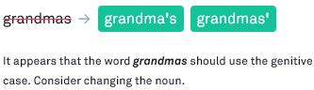  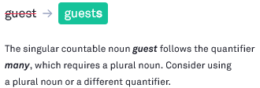 |  | 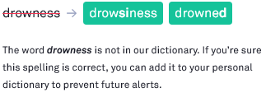
 | NDE | My Holiday  Some time ago, I chose a vacation to the zoo with my brother. We visited Gembira Loka zoo. I going there on Saturday. There are very crowded visitors. We had to walk ver far to surround the entire zoo. Tired but not felt we are enjoy it. We chose to use the train, because I had never been on a train before, and I was so curious how it felt, so I asked my brother to take us to Jogja by train. It felt so good, I wanted to. My brother and I depart from different stations, because we were in a different place at the time. I’m in Klaten and he’s in Solo. But finally we can be in the same seat. After arriving Jogja station, we take the Bus Trans-Jogja. It was the first time for me. There is one thing that is not good, we don’t get tickets back home. A s a result, we have to ride several Bus Trans-Jogja and Bus Jogja-Solo. | 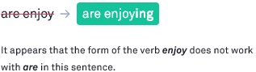  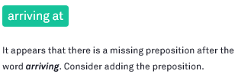 |    | 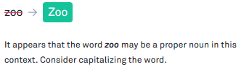
TOTAL |  |  | 57 | 23 | 26
% |  |  | 53.77 | 24.53 | 21.70

GRAMMAR |  |  |  | SPELLING | PUNCTUATION
DETERMINER/ARTICLE | VERB | PREPOSITION | NOUN | SPELLING | PUNCTUATION
25 | 14 | 11 | 7 | 26 | 23
43.86 % | 24.56 % | 19.30 % | 12.28 % | 21.70 | 24.53

