

Content Lists Available at Directory of Open Access Journals (DOAJ)
Al-Falah: Journal of Islamic Economics
Journal Homepage: http://www.journal.iaincurup.ac.id/index/alfalah
DOI: 10.29240/alfalah.v9i1.9604

Analysis of Tax Object Selling Value (NJOP) Data Collection in Improving Land and Building (PBB) Tax Revenue Target at the Regional Revenue Agency Purwakarta District
Dinda Amalia¹, Eti Jumiati^{2*}, Ata³
^{1,3} Sekolah Tinggi Ilmu Ekonomi Wibawa Karta Raharja, ²Sekolah Tinggi Agama Islam Al-Muhajirin
*Corresponding Author. E-mail: etijumiati425@gmail.com
ARTICLE INFO |  | ABSTRACT  Purpose: This research aims to analyze NJOP data collection and how data collection capabilities can increase the achievement of PBB targets in the Bukit Indah City Purwakarta area. The data source in this research was obtained from interviews with informants who are experts in the field of land and building taxes.  Design/Method/Approach: The method used is descriptive qualitative, namely describing the results of the analysis in the form of descriptions from interviews and literature reviews, as well as case studies. Analysis of research results using the NVivo 12 Plus application  Findings: Research findings show that The implementation of NJOP data collection in Purwakarta district has been carried out since 2014, but NJOP data collection is still selective, namely only carried out in several areas/areas of Bukit Indah City/Besland (BIC) and surrounding areas.  Originality/Values: Achievement of PBB targets at the Purwakarta Regency Regional Revenue Agency, to date The Purwakarta district government has made efforts to increase PBB P2 revenues in particular, by providing regulations to facilitate Bapenda's activities.
Article History:
Received: 2024-01-23
Revised: 2024-04-20
Accepted: 2024-05-20

Keywords:
Collection,
NJOP,
Target, Achievement.

Paper Type:
Research Paper

INTRODUCTION
The background of this research is about the implementation of regional autonomy which gives authority to regional governments to manage regional resources and income, including in terms of managing regional taxes. Regional autonomy makes regional governments responsible for finding sources of funding to finance infrastructure development and improve facilities for the public interest, so as to improve the regional economy. Regional governments, including Purwakarta Regency, are trying to increase regional tax revenues, such as Land and Building Tax (PBB), to maximize local original income (PAD) as a source of development financing.
Regional taxes, including Land and Building Tax, are one of the main revenues in the PAD structure in each region. The difference in land value in the Tax Object Sales Value (NJOP) and Land Value Zone (ZNT) often causes uncertainty in local tax revenues and injustice for the government and society. The authority to manage regional taxes lies with the regional government, and in Purwakarta Regency, there are ten types of regional taxes managed, including PBB.
Even though PBB is one of the potential revenues for the region, the achievement of PAD revenue in Purwakarta Regency has still not reached the expected target. Several obstacles such as the lack of income from the regional levies sector and suboptimal regional tax revenue achievements have resulted in the need for local governments to maximize revenue from Land and Building Tax.
The Purwakarta Regency Regional Revenue Agency (BAPENDA) has an important role in optimizing regional income through Land and Building Tax. Therefore, this research will focus on this type of tax and will examine the factors that influence the level of regional tax revenue, especially Land and Building Tax in Purwakarta Regency.
RESEARCH METHOD
This journal article uses qualitative research with the aim of analyzing the potential revenue from Land and Building Tax (PBB-P2) in Purwakarta Regency. The data analysis method used in this research involves interviews, observation and documentation. The research object covers all aspects relevant to PBB-P2 in urban and rural areas of Purwakarta Regency. Data sources consist of primary data obtained through interviews with sources related to PBB-P2 and secondary data originating from documents and reports related to PBB-P2 acceptance.
This research considers the characteristics of a qualitative research approach, where reality is considered holistic, dynamic, and cannot be separated into research variables. The researcher is the key instrument in this qualitative research, because the data sought from the research object is not yet clear and the research design is still temporary, and will develop after the researcher enters the research object.
The data analysis technique uses a market data approach method to find the new Tax Object Sales Value (NJOP) and reduce it from the old NJOP to find the potential for PBB-P2 in Purwakarta Regency. The data that has been collected is analyzed using the NVivo 12 Plus application to help analyze qualitative data more efficiently and effectively.
The results of this data analysis will be presented using charts, diagrams or graphs to show analysis findings that are relevant to the research. Apart from that, this research will also link the PBB-P2 revenue target, revenue realization, and revenue potential to see the extent to which realization has reached optimal potential.
The author used data triangulation in this research to obtain valid data. The triangulation technique involves checking the validity of the data by using other data as a comparison. The author uses source triangulation with multiple methods such as observation, interviews and documentation and compares the results from different informants. Triangulation is also referred to as a validity technique in qualitative research, and to facilitate source triangulation, the author uses Nvivo 12 Plus software.

RESULT AND DISCUSSION
Results
  - Validity Test Results
The implementation of data collection on the Selling Value of Tax Objects (NJOP) in increasing the achievement of the Land and Building Tax (PBB) Revenue Target at Bapenda Purwakarta Regency, as follows:
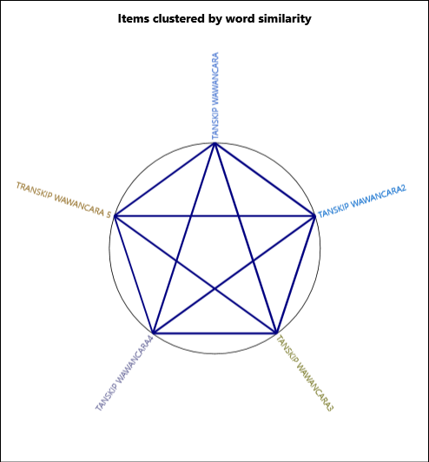

Figure 1. Validity Test Results
Source: Data processed by NVivo 12 Plus

From the diagram above, the five informants have similar content in their interview results or are connected to each other, meaning that the five informants have similar content, so it can be said that the data is valid. Furthermore, this data can be used for discussion in the next analysis and can be explained using the rule limits as explained in the summary results as follows:
Table 1. Validity Test Results
File A | File B | Pearson correlation coefficient
Files\\INTERVIEW\\TANSKIP INTERVIEW3 | Files\\INTERVIEW\\TANSKIP INTERVIEW2 | 0.989065
Files\\INTERVIEW\\TANSKIP INTERVIEW2 | Files\\INTERVIEW\\TANSKIP INTERVIEW | 0.986521
Files\\INTERVIEW\\TANSKIP INTERVIEW3 | Files\\INTERVIEW\\TANSKIP INTERVIEW | 0.979949
Files\\INTERVIEW\\TANSKIP INTERVIEW4 | Files\\INTERVIEW\\TANSKIP INTERVIEW3 | 0.948097
Files\\INTERVIEW\\TANSKIP INTERVIEW4 | Files\\INTERVIEW\\TANSKIP INTERVIEW2 | 0.945028
Files\\INTERVIEW\\TANSKIP INTERVIEW4 | Files\\INTERVIEW\\TANSKIP INTERVIEW | 0.920219
Files\\INTERVIEW\\INTERVIEW TRANSKIP 5 | Files\\INTERVIEW\\TANSKIP INTERVIEW3 | 0.89597
Files\\INTERVIEW\\INTERVIEW TRANSKIP 5 | Files\\INTERVIEW\\TANSKIP INTERVIEW | 0.886207
Files\\INTERVIEW\\INTERVIEW TRANSKIP 5 | Files\\INTERVIEW\\TANSKIP INTERVIEW2 | 0.885449
Files\\INTERVIEW\\INTERVIEW TRANSKIP 5 | Files\\INTERVIEW\\TANSKIP INTERVIEW4 | 0.776004
Source: Data processed with NVivo 12 Plus (2023)
The closeness between each interview result 1-5 is very high. The benchmark for a correlation below 0.7 is said to be less similar. The results of the validity test using NVivo software show that the correlation value is more than 0.7, which is in accordance with the provisions. The conditions for high and low validity can be seen from the table below:
Table 2. Validity Indicators
Strength of Association | Coeficien.r
Strength of Association | Positive | Negative
Small | 0.1 to 0.3 | -0.1 to -0.3
Medium | 0.3 to 0.5 | -0.3 to -0.5
Large | 0.5 to 1.0 | -0.5 to -1.0
Source: Processed data (2023)

  - Coding Interview Data
Codingis a requirement to obtain high quality qualitative data analysis results. Coding must be carried out so that Qualitative data is identified, grouped and managed systematically so that the research will be transparent for other researchers who wish to review or repeat the research. In the table below, the coding test results are explained, as follows:
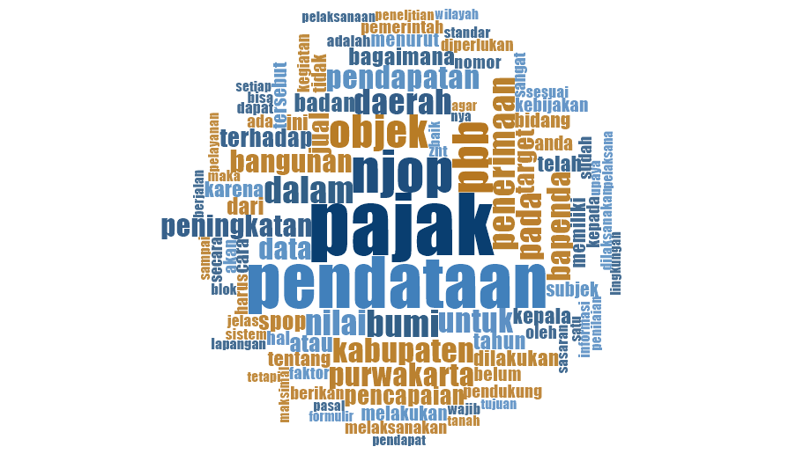
Figure 2 Coding Results Data
Source: Data processed by NVivo 12 Plus

From the data above, it can be concluded that the bigger the letters displayed in the picture, the more frequently the word is conveyed, both from the five informants and from the literature review the words most often mentioned: tax, NJOP, data collection, object, increase, land tax. and buildings, the UN and so on.
Meanwhile, coding according to the analysis chart hierarchy can be explained in the image below:

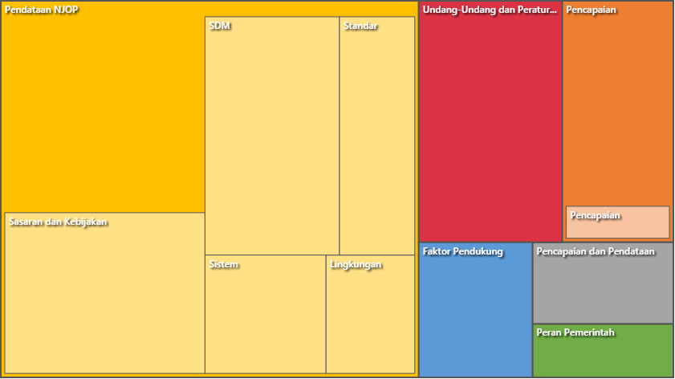
Figure 3 Hierarchy of Rectangular Data Analysis Chart
Source: Data processed using NVivo 12 Plus

From this picture it can be concluded that the coding results in this research, the most words are NJOP data collection can be seen from the area in the diagram. In the implementation of land and building tax collection, Data collection is the most important stage in the NJOP determination process. Because, errors in this process will cause errors in all subsequent stages. At this stage, before the tax objects are listed and entered into the data, the results are finally used to estimate how much tax is owed in the SPPT. Next, assessment, determination, administration, collection and service are carried out. The final result of the data collection is that a Research Result Report (LHP) is published which is then transferred to the Operator Console (OC) to be given a Tax Object Number (NOP) and an assessment is carried out.
  - Comparison of the Phenomenon of Tax Object Data Collection and Retribution Achievements
In this case the author wants to know the relationship between NJOP data collection and levy achievements. To carry out constant comparative analysis, the researcher first carries out a classification which aims to provide descriptive information about data sources, subjects, places, or other cases in the research. There are three types of data classification in NVivo with different functions, namely source classifications, case classifications, and relationship types. Source classifications are used to store all data source or bibliographic information about research, case classifications are used to provide research demographic information, and relationship types are a special type of classification to obtain relationship patterns between each data analysis unit.
Below are explained the results of the comparison test by Nvivo 12 plus, as follows:

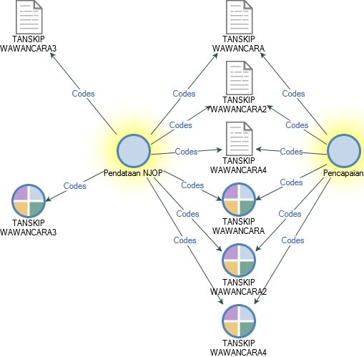
Figure 4.Comparison test results
Source: Data processed using the Nvivo 12 Plus application

From this figure it can be seen that NJOP data collection is related to achieving the target for property tax revenue at the Regional Revenue Agency (Bapenda) which is supported by the results of interviews from informants 1, 2, 4 and 5, while the results of interviews from informant 3 do not support this relationship.
Discussion
Implementation of data collectionSales Value of Tax Objects (NJOP) in increasing the Achievement of Land and Building Tax (PBB) Revenue Targets in the Purwakarta Regency Bapenda
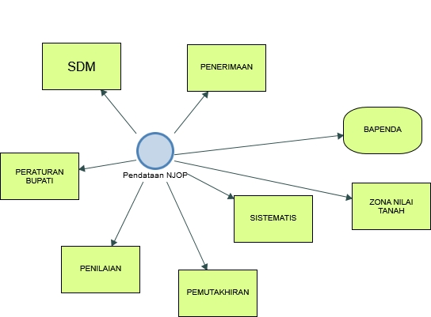

The picture explains the data collection on sales value of tax objects (NJOP) which includes several aspects, namely: 1) Human resources, where NJOP data collection is carried out by the Purwakarta Regency Regional Revenue Agency (Bapenda). Even though Bapenda is not an expert in the field of taxation based on educational expertise, they make efforts by coordinating with relevant agencies and technical guidance (bintek) activities in the field of taxation to manage taxes; 2) Tax revenue, namely NJOP data collection contributes to the policy of increasing revenue receipts for local governments, considering that NJOP is an important policy in the development context in Purwakarta Regency; 3) Regulations in regent regulations: NJOP data collection is officially regulated in Regent Regulation Number 52 of 2017 article 3 concerning Data Collection on PBB Objects and Subjects. Land NJOP is determined based on a Regional Head Decree and reflects the land value zone which is supported by data such as fair market value and other comparative data.
NJOP data collection is a systematic effort to obtain accurate data regarding the value of tax objects, especially land. Through a data triangulation approach, information from various sources, including human resources at Bapenda, tax revenues, and regent regulations, is used as a reference for assessing and updating the NJOP value in Purwakarta Regency.
It was concluded that the implementation of NJOP PBB data collection in Purwakarta Regency involved Bapenda with the support of the Regional Government, and this effort was based on the regulations governing PBB and NJOP data collection.
Achievement of PBB Targets at the Regional Revenue Agency of Purwakarta Regency
The Purwakarta Regency Government has made efforts to increase PBB P2 revenues by providing regulations that facilitate Bapenda's activities. NJOP data collection is an important indicator in achieving PBB revenue targets and Regional Original Income (PAD). Through NJOP data collection, land and building NJOP data is updated, which results in an increase in the NJOP value and automatically increases the PBB amount. NJOP data collection has an impact on increasing PBB revenue targets and achievements.
Purwakarta Regency Bapenda has carried out NJOP data collection activities in recent years to maximize Regional Original Income (PAD). NJOP data collection has a significant effect on achieving PBB and PAD revenue targets. NJOP data collection plays a major role in increasing tax revenues, especially PBB, because the current NJOP value is still far from fair market value. Efforts to find market value through field surveys and NJOP adjustments are expected to increase tax revenues in the future. NJOP data collection has a significant impact in achieving PBB and PAD revenue targets. Bapenda must explore existing potential by making adjustments to the NJOP so that tax revenue targets and achievements are balanced. Regent's regulation no. 52 of 2017 regulates procedures for collecting data on PBB P2 objects and subjects, including two methods of data collection, namely passive and active.

CONCLUSION
The implementation of NJOP data collection in Purwakarta Regency has been carried out since 2014 in a passive and active manner in accordance with Regent Regulation Number 52 of 2017 concerning Data Collection on PBB Objects and Subjects. This data collection was carried out to increase Regional Original Income (PAD) with the authority of the Purwakarta Regency Regional Revenue Agency, especially in the field of Data Collection and Assessment. NJOP data collection is carried out selectively only in certain regions/areas such as Bukit Indah Citi/Besland (BIC) and its surroundings. After data collection is carried out, assessment or updating of NJOP adjustments is carried out a maximum of once every 3 years, taking into account certain areas.
Achieving the PBB target at the Regional Revenue Agency of Purwakarta Regency depends on the efforts made by the district government to increase PBB P2 revenues. One of them is by providing regulations that facilitate Bapenda's activities and conducting field surveys to find market values ​​that can be used as comparison prices.
NJOP data collection plays an important role in achieving PBB revenue targets. The higher the PBB target set by the regional government, the Regional Revenue Agency must continue to explore the potential through data collection and NJOP adjustments to achieve the desired tax revenue targets and achievements.

REFERENCES
Abdussamad, Zuchri. Metode Penelitian Kualitatif. Makasar: CV. Syakir Media Press, 2021.
Aritonang, Aritonang, and Lasindah Nadya Suharni. “Faktor Penghambat Pencapaian Target Penerimaan Pajak Bumi Dan Bangunan Sektor Perdesaan Dan Sektor Perkotaan (PBB-P2) Di Kabupaten Deli Serdang.” Repositori Institusi Universitas Sumatera Utara, 2020.
Budiastuti, Dr Dyah, and Agustinus Bandur. “Validitas Dan Reliabilitas Penelitian,” 2018.
Effendi, Mukhrizal, Syahrizal Efendi Lubis, Fandhi Alfiansyah, Fachrul Rozi, Raja Saljukdin, Agus Aman Siregar, and Laila Tanjung. “Analisis Potensi Pajak Bumi Dan Bangunan Sektor Pedesaan Dan Perkotaan Di Kabupaten Labuhanbatu Utara (Studi Kasus Kecamatan Kualuh Hulu).” Warta Dharmawangsa 14, no. 4 (October 16, 2020): 615–26. https://doi.org/10.46576/wdw.v14i4.892.
Fadli, Muhammad Rijal. “Memahami desain metode penelitian kualitatif” 21, no. 1 (2021).
Kumoro, Merlinda Putri, and Alia Ariesanti. “Potensi Pajak Bumi Dan Bangungan Sektor Perdesaan Dan Perkotaan Kota Yogyakarta Dan Kontribusinya Terhadap Kemandirian Daerah.” Riset Akuntansi dan Keuangan Indonesia 2, no. 1 (April 14, 2017): 75–90. https://doi.org/10.23917/reaksi.v2i1.3684.
Kurnia, Sunaryo Dedy, and M Adkha Yulianandha. “Pembuatan Zona Nilai Tanah Untuk Updating Nilai Jual Objek Pajak Bumi Dan Bangunan Perdesaan Dan Perkotaan (Studi Kasus : Kelurahan Pembataan, Kecamatan Murung Pudak, Kabupaten Tabalong),” 2019.
Mustofa, Sahara, and Fadlil Usman. “Perubahan Nilai Jual Objek Pajak Sektor Perkebunan Tahun Pajak 2020 Terhadap Tahun Pajak 2019 (Studi Kasus Di Kantor Pelayanan Pajak Pratama Salatiga).” Educoretax Vol. 1, No. 3 (2021).
Nainggolan, Edisah Putra. “Analisis Pengawasan Dalam Meningkatkan Kinerja Penerimaan Pajak Bumi Dan Bangunan Pada Badan Pengelolaan Pajak Dan Retribusi Daerah Kota Medan,” 2018.
Ningrum, Dewi Agustya, and Fitria Ulandari. “Penetapan dan Pembayaran Pajak Bumi dan Bangunan Perdesaan Perkotaan (PBB-P2) di BPPD Kabupaten Sidoarjo” 8, no. 1 (2021).
Noor, Muh Yasin. “Efektivitas Penerimaan Pajak Bumi Dan Bangunan (Pbb-P2) Di Desa Tibona Kecamatan Bulukumpa Kabupaten Bulukumba.” Amnesty: Jurnal Riset Perpajakan 3, no. 2 (November 29, 2020): 134–50. https://doi.org/10.26618/jrp.v3i2.4409.
Prawitra, Devry, and Achmad Lutfi. “Analisis Pengelolaan PBB-P2 Di Provinsi DKI Jakarta Tahun 2015 - 2019.” Jurnal Sekuritas (Saham, Ekonomi, Keuangan Dan Investasi) Vol. 4, No. 3 (2021).
Rahadi, Dedi Rianto. Konsep Penelitian Kualitatif Plus Tutorial NVivo. Bogor: PT. Filda Fikrindo, 2020.
Saputro, Rudi, Nengah Sudjana, and Devi Farah Azizah. “Efektivitas Penerimaan Pajak Bumi Dan Bangunan Perdesaan Dan Perkotaan (Pbb P2) Terhadap Peningkatan Penerimaan Pendapatan Asli Daerah (PAD),” 2014.

Devry Prawitra and Achmad Lutfi, “Analisis Pengelolaan PBB-P2 Di Provinsi DKI Jakarta Tahun 2015 - 2019,” Jurnal Sekuritas (Saham, Ekonomi, Keuangan Dan Investasi) Vol. 4, No. 3 (2021).
Mukhrizal Effendi et al., “Analisis Potensi Pajak Bumi Dan Bangunan Sektor Pedesaan Dan Perkotaan Di Kabupaten Labuhanbatu Utara (Studi Kasus Kecamatan Kualuh Hulu),” Warta Dharmawangsa 14, no. 4 (October 16, 2020): 615–26, https://doi.org/10.46576/wdw.v14i4.892.
Merlinda Putri Kumoro and Alia Ariesanti, “Potensi Pajak Bumi Dan Bangungan Sektor Perdesaan Dan Perkotaan Kota Yogyakarta Dan Kontribusinya Terhadap Kemandirian Daerah,” Riset Akuntansi dan Keuangan Indonesia 2, no. 1 (April 14, 2017): 75–90, https://doi.org/10.23917/reaksi.v2i1.3684.
Rudi Saputro, Nengah Sudjana, And Devi Farah Azizah, “Efektivitas Penerimaan Pajak Bumi Dan Bangunan Perdesaan Dan Perkotaan (Pbb P2) Terhadap Peningkatan Penerimaan Pendapatan Asli Daerah (PAD),” 2014.
Sahara Mustofa and Fadlil Usman, “Perubahan Nilai Jual Objek Pajak Sektor Perkebunan Tahun Pajak 2020 Terhadap Tahun Pajak 2019 (Studi Kasus Di Kantor Pelayanan Pajak Pratama Salatiga),” Educoretax Vol. 1, No. 3 (2021).
Muh Yasin Noor, “Efektivitas Penerimaan Pajak Bumi Dan Bangunan (Pbb-P2) Di Desa Tibona Kecamatan Bulukumpa Kabupaten Bulukumba,” Amnesty: Jurnal Riset Perpajakan 3, no. 2 (November 29, 2020): 134–50, https://doi.org/10.26618/jrp.v3i2.4409.
Aritonang Aritonang and Lasindah Nadya Suharni, “Faktor Penghambat Pencapaian Target Penerimaan Pajak Bumi Dan Bangunan Sektor Perdesaan Dan Sektor Perkotaan (PBB-P2) Di Kabupaten Deli Serdang,” Repositori Institusi Universitas Sumatera Utara, 2020.
Edisah Putra Nainggolan, “Analisis Pengawasan Dalam Meningkatkan Kinerja Penerimaan Pajak Bumi Dan Bangunan Pada Badan Pengelolaan Pajak Dan Retribusi Daerah Kota Medan,” 2018.
Muhammad Rijal Fadli, “Memahami desain metode penelitian kualitatif” 21, no. 1 (2021).
Zuchri Abdussamad, Metode Penelitian Kualitatif (Makasar: CV. Syakir Media Press, 2021).
Dedi Rianto Rahadi, Konsep Penelitian Kualitatif Plus Tutorial NVivo (Bogor: PT. Filda Fikrindo, 2020).
dr Dyah Budiastuti And Agustinus Bandur, “Validitas Dan Reliabilitas Penelitian,” Mitra Wacana. 2018.
Dewi Agustya Ningrum and Fitria Ulandari, “Penetapan dan Pembayaran Pajak Bumi dan Bangunan Perdesaan Perkotaan (PBB-P2) di BPPD Kabupaten Sidoarjo” 8, no. 1 (2021).
Sunaryo Dedy Kurnia and M Adkha Yulianandha, “Pembuatan Zona Nilai Tanah Untuk Updating Nilai Jual Objek Pajak Bumi Dan Bangunan Perdesaan Dan Perkotaan (Studi Kasus : Kelurahan Pembataan, Kecamatan Murung Pudak, Kabupaten Tabalong),” 2019.

