E-Gold and Investment Challenges:

How Digital Gold Works for Economic Recovery after Covid-19 Pandemic

Andi Bahri S1*, Hardyansyah Yusuf2, Damirah3, Khairuddin Yusup4

1,2,3 *Institut Agama Islam Negeri Parepare, Sulawesi Selatan Indonesia*

4 *UIN Datokarama Palu, Sulawesi Tengah, Indonesia*

*Corresponding Author *E-mail*: [andibahris@iainpare.ac.id](mailto:andibahris@iainpare.ac.id)

|  |  |  |
| --- | --- | --- |
| **ARTICLE INFO** |  | ABSTRACT **Purpose**:This study aims to analyze the urgency of gold (e-gold or digital gold) invested for economic recovery after Covid-19 pandemic.  **Design/Method/Approach**: This study applied descriptive qualitative with a literature review approach. The data collected through documentation from authoritative agent on investment business and observation on economic turbulence during the days of Covid-19 pandemic. The data obtained from market review reports, finance symposium summary, economic and business news, article journals, and some relevant books. While the data analysis technique developed base on conclusion drawing technique in order to fine out a systematical analysis as well as objective conclusion.  **Findings:** The results show that gold investment is really recommended because more profitable and gold performed relatively better than many other assets in the early pandemic stages. Besides, the digital transaction was appointed in the Qur’an, Hadith and *`Ijma’*. Meanwhile, there are two opinions regarding allowance and prohibition related to digital gold investment. First, it is forbidden due to the payment by credit not cash. In addition to the four *madzhabs'* opinion, this transaction must be complied the cash transaction requirements in order to prevent the usury. The second is Ibn Taimiyah's opinion and DSN-MUI regulation shown that as long as the transaction fulfills the requirement, it is allowed.  **Originality/Values**: The main contribution of this study concern on filling the gap of how urgency the e-gold investment for recovering the economic impact of pandemic and how e-gold investment according to the Islamic economic perspective. |
| Article History:  Received:  Revised:  Accepted: |
| **Keywords:**  1. E-Gold;  2. Economic Recovery;  3. Covid-19;  4. Islamic Economy;  5. Madzhab |
| **Paper Type:**  Research Paper |

# INTRODUCTION

COVID-19 is known to be frequently associated with coagulopathy and thrombotic complications (Coagulopathy et al., 2021). Coronavirus disease 2019 (COVID-19) is caused by coronavirus 2 causing severe acute respiratory illness (SARS-CoV-2). In December of 2019, the new virus was first found in a cluster of individuals with atypical pneumonia in Wuhan, China. By the end of January 2020, it was evident that illnesses were efficiently spreading from person to person and that there was a broader clinical spectrum of infections (Tsang et al., 2020). Globally, as of 4:15pm CET, 24 January 2023, there have been 664,618,938 confirmed cases of COVID-19, including 6,722,949 deaths, reported to WHO. As of 16 January 2023, a total of 13,131,550,798 vaccine doses have been administered (World Health Organization, 2023b). In Indonesia, from 3 January 2020 to 4:15pm CET, 24 January 2023, there have been 6,728,402 confirmed cases of COVID-19 with 160,793 deaths, reported to WHO. As of 16 January 2023, a total of 444,303,130 vaccine doses have been administered (World Health Organization, 2023a).

The COVID-19 pandemic has had an extraordinary impact on the world economy and the affected countries. The threat of recession and depression is in sight. To prevent, or at least reduce, the rate of transmission, a number of affected countries have implemented lock-downs, regional quarantines, and large-scale social restrictions. A number of flights were suspended in many countries. Land and sea transportation are also restricted. A number of industries stopped production (Junaedi & Salistia, 2020). Based on study which was conducted by Nasution at all (2020) shown the impact of the Covid-19 pandemic resulted in a lack of investor trust in the market, which in turn caused the market to tend to be negative. In order to deliver economic direction, strategic fiscal and monetary actions are required. In addition, the slow pace of the world economy, particularly Indonesian export activities to China, has a substantial impact on the economy of Indonesia (Nasution et al., 2020).

As on 1st January 2023, Government announce the transition phase of Covid-19 status from pandemic to endemic (Saubani, 2022). Even though, effect of pandemic Covid-19 still affected to the community especially for economic sectors. The economic recession led to an increase in unemployment, especially among micro- and small-scale firms or domestic industries, and the pandemic COVID-19 contributed to an increase in poverty. Greater numbers of poor families were found in locations with near-poor and vulnerable households (Aeni, 2021).

In its research entitle "Is a Worldwide Crisis Imminent?" the World Bank anticipates that a global economic recession may occur in 2023. In 2022, policymakers were more terrified by the possibility of a global recession as they witnessed the rapid deterioration of growth prospects amid growing inflation. This prediction feels even more real with several indications that have started to occur, such as the aggressive increase in benchmark interest rates by the central banks of various countries in an effort to reduce the inflation rate (Mahdiyan, 2023). World Bank analysis indicates that the global economy could escape a recession even if additional monetary policy tightening beyond current market expectations is needed to reduce inflation. Nonetheless, it would require the additional tightening to be implemented in such a way as to generate an orderly adjustment in financial markets. More importantly, policymakers must employ all of their available “tools” to stay ahead of inflation and prevent the likelihood of a steeper downturn in economic growth (Guénette et al., 2022).

One of the solutions to escape and or prevent the worst effect of economic recession for the community is minimizing the outcome and prefer for invest. Studies which was conducted by Bouri et al. on 2020 have shown mixed results regarding the safe-haven asset properties of gold during the COVID-19 pandemic (Bouri et al., 2020). In this modern era, many millennial are saving aside a portion of their salary or pocket money to buy gold with the hope of achieving a long-term profit (A. Fauziah & Surya, 2016). One of investment that millennial preferred is Gold investment. Gold investment is one of the most secure and profitable investments. Gold is an investment object whose value tends to increase over time, so gold investment is almost always profitable with low risk (M. R. Fauziah, 2019).

Science and technology have evolved over time and internet being one of innovation that has had a significant impact. Mastery in technology becomes prestige and indicator of developed country especially in this globalization era including Indonesia and it’s marked by development of e-commerce business. Technological developments and digitalization indirectly changes individual or community mindset to use online media and it’s known as e-life. E-life have a lot of various type which are e-commerce, e-library, e-government, e-medicine, e-biodiversity, e-laboratory and so on (Muhammad, 2020).

Based on above explanation, the research aims to analyze the urgency of e-gold investment for recovering the economic impact of pandemic and to analyze the e-gold investment base on the Islamic economic perspective.

# RESEARCH METHOD

This study applied descriptive qualitative with a literature review or library research approach. The data collected through documentation from authoritative agent on investment business and observation on economic turbulence impact during the days of Covid-19 pandemic. The data obtained from market review reports, finance symposium summary, economic and business news, article journals, and some relevant books. While the data analysis technique developed base on conclusion drawing technique in order to fine out a systematical analysis as well as objective conclusion.

# RESULT AND DISCUSSION

## 1. Gold Investment

Gold is an excellent investment alternative since it is more stable than other financial assets. The reasons include gold as an inflation hedge, gold investment as an attractive alternative to fixed income investment, gold investment as a less risky investment than stock investment, and currency exchange rates and their impact on gold investment returns (Panda & Sethi, 2016). Despite successive economic and financial crises, the value of the precious metal has remained high since ancient times. In recent years, currency values have changed due to the foreign exchange market, the price of crude oil, and inflation; similarly, the gold rate has been unstable (S et al., 2016).

By investing in or purchasing it, investors and consumers assume a higher level of risk. Predicting the price of gold in this situation is necessary not only to offer people hope but also to protect their money, as its value fluctuates dramatically. Numerous corporations trade these two units as stocks, and predicting the stock price is always a challenging problem due to its nontrivial nonlinearity. In order to shield themselves from political, financial, and social disasters, stockholders will dedicate themselves to this endeavor. Investing in gold is beneficent since there is no "crop rotation market fluctuation." In addition to the individual investors of multinational corporations, other individuals also invested in gold reserves.

In the meantime, this precious metal has begun to resemble currency to the extent that the government is likely to raise its gold reserve (K et al., 2017). Most people think that one advantage of gold because of its high liquidity control, it will help in difficult times (Pinto, 2016).

## 2. Trend of Gold Price

Trend of gold price is a subject of prediction and forecasting because it fluctuates continuously. Prices for gold might change from time to time. According to data from the Logam Mulia official website, there have been significant fluctuations in the gold price during the past ten years. The fluctuation trend of gold price in Indonesia is shown in Figure 1 (Harga Emas, n.d.).

**Figure 1.**

Fluctuation Trend of Gold Price

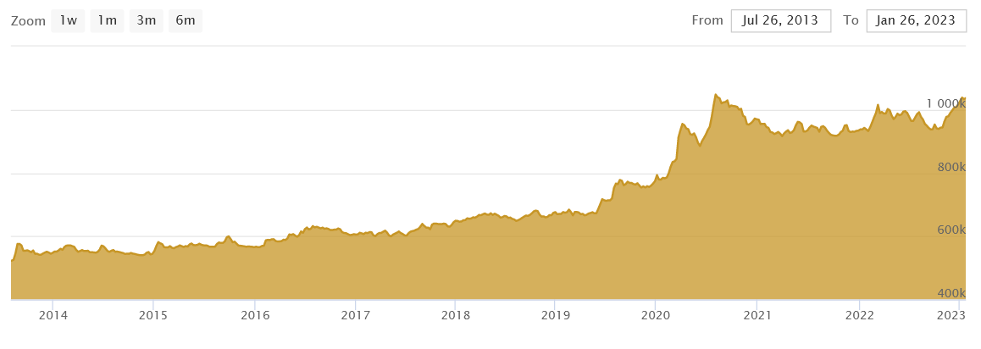

Source: Logam Mulia (accessed on January 2023)

Despite the global COVID-19 pandemic, the price of gold has tended to rise over the past three years. According to previous research, the value of stocks, the price of oil, the rate of inflation, and currency exchange rates all have an impact on gold prices (Syukuri Nur, 2020). Gold price during pandemic is shown in Figure 2 (Harga Emas, n.d.).

**Figure 2.**

Trend of Gold Price during Pandemic

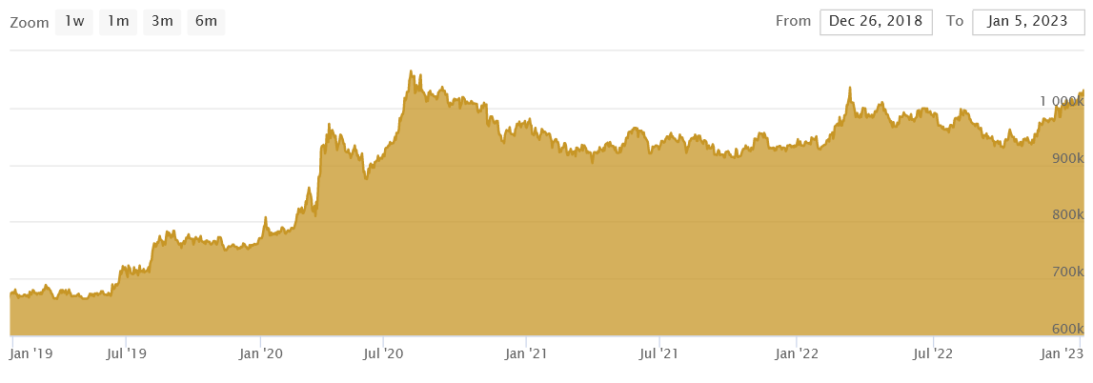

Source: Logam Mulia (accessed on January 2023)

Figure 2 not only displays a fluctuating graph, but also a significant increase of gold prices before, during, and after the COVID-19 pandemic. It means gold investment is very profitable. It is related to previous research that mentioned gold performed relatively better than many other assets in the early pandemic stages (Akhtaruzzaman et al., 2021).

## 3. Digital Gold on Islamic Economic Perspective

Study which was conducted by Arafat and Krismono (2022) shown that there are 2 argument or opinion related to digital gold investment, the first is digital gold investment is forbidden because the payment by credit not cash. Four *madzhabs'* opinion is transaction must be meet the requirements where the transaction must be done in cash in order to prevent the usury (included in usury nasi'ah). The second are Ibn Taimiyah's opinion and DSN-MUI regulation shown that as long the transaction fulfill the requirement, it is allowed (Arafat, 2022).

## CONCLUSION

Gold investment is really recommended because more profitable and gold performed relatively better than many other assets in the early pandemic stages. Besides that, trend of gold price showing the the fluctuation graph and the price is increase timely. And also, digital transaction is appointed on al-qur’an, hadith and *`ijma’*. Meanwhile, there are two opinions regarding allowance and prohibition related to digital gold investment. First, it is forbidden because the payment by credit not cash. Four *madzhabs'* opinion are transaction must be meet the requirements where the transaction must be done in cash in order to prevent the usury. The second are Ibn Taimiyah's opinion and DSN-MUI regulation shown that as long the transaction fulfill the requirement, it is allowed. Deeply research is require in order to change the community perspective to invest in digital gold.

**REFERENCES**

Aeni, N. (2021). Pandemi COVID-19: Dampak Kesehatan, Ekonomi, & Sosial. *Jurnal Litbang: Media Informasi Penelitian, Pengembangan Dan IPTEK*, *17*(1), 17–34. https://doi.org/10.33658/jl.v17i1.249

Akhtaruzzaman, M., Boubaker, S., Lucey, B. M., & Sensoy, A. (2021). Is gold a hedge or a safe-haven asset in the COVID–19 crisis? *Economic Modelling*, *102*(June), 105588. https://doi.org/10.1016/j.econmod.2021.105588

Arafat, M. (2022). Tinjauan Hukum Islam Terhadap Investasi Emas Online Melalui TokopediaEmas. *Jurnal At-Tsaman*, *2*(1), 152–161.

Budiman, B., Adawiyah, E. R., Syukri, M., Ibadurohmah, I., & Wahrudin, U. (2023). Effect of Electronic Money Transactions on Customer Satisfaction According to Sharia Economy (Case Study at STAI La Tansa Mashiro). *AL-FALAH: Journal of Islamic Economics*, *8*(1), 97-118.

Bouri, E., Shahzad, S. J. H., Roubaud, D., Kristoufek, L., & Lucey, B. (2020). Bitcoin, gold, and commodities as safe havens for stocks: new insight through wavelet analysis. *The Quarterly Review of Economics and Finance*, *77*, 156–164. https://www.sciencedirect.com/science/article/abs/pii/S1062976920300326

Chong, D., & Ali, H. (2022). Literature Review: Competitive Strategy, Competitive Advantages, and Marketing Performance on E-Commerce Shopee Indonesia. *Dinasti International Journal of Digital Business Management*, *3*(2), 299–309. https://www.dinastipub.org/DIJDBM/article/view/1198

Claessens, S., & Kose, M. A. (2023). Recession: When Bad Times Prevail. *International Monetory Fund*. https://www.imf.org/external/pubs/ft/fandd/basics/recess.htm

Coagulopathy, C.--associated, Iba, T., Warkentin, T. E., Thachil, J., Levi, M., & Levy, J. H. (2021). Proposal of the Definition for. *J Clin Med*, *10*(191), 1–9.

Darmastuti, S., Juned, M., Susanto, F. A., & Al-Husin, R. N. (2021). COVID-19 dan Kebijakan dalam Menyikapi Resesi Ekonomi: Studi Kasus Indonesia, Filipina, dan Singapura. *Jurnal Madani: Ilmu Pengetahuan, Teknologi, Dan Humaniora*, *4*(1), 70–86. https://doi.org/10.33753/madani.v4i1.148

Departemen Komunikasi, B. I. (2017). *Peraturan Bank Indonesia No.19/12/PBI/2017 tentang Penyelenggaraan Teknologi Finansial*. https://www.bi.go.id/id/publikasi/peraturan/Pages/pbi_191217.aspx

DSN-MUI. (n.d.). *No Title*. https://dsnmui.or.id/

Fauziah, A., & Surya, M. E. (2016). Peluang Investasi Emas Jangka Panjang melalui Produk Pembiayaan Bsm Cicil Emas. *Islamadina*, *XVI*(1), 57–73.

Fauziah, M. R. (2019). INVESTASI LOGAM MULIA (EMAS) DI PENGGADAIAN SYARIAH DALAM PERSFEKTIF HUKUM EKONOMI SYARIAH. *E-Journal Institut Agama Islam Negeri Ambon*, *XV*(1).

Guénette, J. D., Kose, M. A., & Sugawara, N. (2022). *Is a Global Recession Imminent? EFI Policy Note 4*. *September*, 1–37. https://www.worldbank.org/en/research/brief/global-recession

Hardiati, N., & Bisri, H. (2020). TINJAUAN HUKUM INVESTASI TERHADAP PASAR MODAL SYARIAH. *Jurnal Indonesia Sosial Sains*, *1*(September), 132–141.

*Harga Emas*. (n.d.). https://www.logammulia.com/id/harga-emas-hari-ini

Hayati, M. (2016). Investasi menurut perspektif ekonomi islam. *Journal of IslamicEconomics and Business*, *1*(April), 66–78.

Hendrianto, H., & Yakin, I. A. (2023). The Diversity of Contemporary Islamic Economic Thoughts of Schools: Baqir As-Sadr, Mainstream and Alternative. *AL-FALAH: Journal of Islamic Economics*, *8*(1), 83-96.

Huda, N., & Nasution, M. E. (2007). *Investasi Pada Pasar Modal Syariah*. Kencana.

Junaedi, D., & Salistia, F. (2020). Dampak Pandemi COVID-19 Terhadap Pertumbuhan Ekonomi Negara-Negara Terdampak. In *Simposium Nasional Keuangan Negara* (pp. 995–1115).

K, R. S., Manav, S., K, S. R., & J, S. (2017). *Gold Price Estimation Using A Multi Variable Model*.

Mahdiyan, A. (2023, January 25). Perekonomian dunia diprediksi akan dihantam resesi tahun 2023, bagaimana dengan pembangunan infrastruktur? *KPBU KEMENKEU*. https://kpbu.kemenkeu.go.id/read/1173-1508/umum/kajian-opini-publik/perekonomian-dunia-diprediksi-akan-dihantam-resesi-tahun-2023-bagaimana-dengan-pembangunan-infrastruktur

Muhammad, M. M. (2020). Transaksi E-Commerse Dalam Ekonomi Syariah. *El-Iqthisadi : Jurnal Hukum Ekonomi Syariah Fakultas Syariah Dan Hukum*, *2*(1), 76. https://doi.org/10.24252/el-iqthisadi.v2i1.14021

Nasution, D. A. D., Erlina, E., & Muda, I. (2020). Dampak Pandemi COVID-19 terhadap Perekonomian Indonesia. *Jurnal Benefita*, *5*(2), 212. https://doi.org/10.22216/jbe.v5i2.5313

Panda, R., & Sethi, M. (2016). Gold as an Investment Option in India: Myth and Reality. *Indian Journal of Finance*, *10*(5). https://ssrn.com/abstract=2878636

Pinto, M. J. (2016). An Analysis on Commodity Market with Special Reference to Gold. *International Journal of Multi-Disciplinary Research*, *1*(1), 1–8.

Rafika, N. A. A. (2021). *TINJAUAN HUKUM ISLAM TENTANG INVESTASI EMAS ANEKA TAMBANG (Studi pada Pengguna Aplikasi Tamasia di Bandar Lampung)*. UNIVERSITAS ISLAM NEGERI RADEN INTAN LAMPUNG.

Ranaswijaya, R. (2023). Analysis of Monzer Kahf's Thoughts on the Phenomenon of Consumption in Modern Society. *AL-FALAH: Journal of Islamic Economics*, *8*(1), 119-132.

S, K. C., M, S., & S, N. S. (2016). Forecasting Gold Prices Based on Extreme Learning Machine. *International Journal of Computers, Communications & Control*, *11*(3), 372.

Saubani, A. (2022). PPKM Dicabut, Indonesia Masuki Masa Transisi dari Pandemi ke Endemi. *Republika.Co.Id*. https://www.republika.co.id/berita/rnpn7r409/ppkm-dicabut-indonesia-masuki-masa-transisi-dari-pandemi-ke-endemi

Syukuri Nur, M. (2020). Tinjauan Pustaka Sistematis. *Tinjauan Pustaka Sistematis*, *26861089*(June), ix.

Tsang, T. K., Wu, P., Lin, Y., Lau, E. H. Y., Leung, G. M., & Cowling, B. J. (2020). Effect of changing case definitions for COVID-19 on the epidemic curve and transmission parameters in mainland China: a modelling study. *The Lancet Public Health*, *5*(5), e289–e296. https://doi.org/10.1016/S2468-2667(20)30089-X

Udovita, P. V. M. V. D. (2020). Conceptual Review on Dimensions of Digital Transformation in Modern Era. *International Journal of Scientific and Research Publications (IJSRP)*, *10*(2), p9873. https://doi.org/10.29322/ijsrp.10.02.2020.p9873

World Health Organization. (2023a). *WHO Coronavirus (COVID-19) Country Overview*. WHO Official Website. https://covid19.who.int/region/searo/country/id

World Health Organization. (2023b). *WHO Coronavirus (COVID-19) Dashboard Overview*. WHO Official Website. https://covid19.who.int/

Yarli, D. (2018). Analisis Akad Tijarah Pada Transaksi Fintech Syariah Dengan Pendekatan Maqhasid. *YUDISIA : Jurnal Pemikiran Hukum Dan Hukum Islam*, *9*(2). https://doi.org/10.21043/yudisia.v9i2.4766