**Content Lists Available at Directory of Open Access Journals (DOAJ)**

**Al-Falah: Journal of Islamic Economics**

**Journal Homepage:** [**http://www.journal.iaincurup.ac.id/index/alfalah**](http://www.journal.iaincurup.ac.id/index/alfalah)

**DOI: 10.29240/alfalah.v7i1.3607**



**The Effect of HCM Practices and HRM Development and Islamic Economics as Mediation on Employee Commitment in Purwakarta Regency**

*Eti Jumiati1

**1**Sekolah Tinggi Agama Islam Al-Muhajirin Purwakarta

*Corresponding E-mail: etijumiati425@gmail.com

|  |  |  |
| --- | --- | --- |
| **ARTICLE INFO** |  | ABSTRACT **Purpose**: This paper examines the “effect of human capital management practices and HRM Development and the Islamic economics as mediation on evaluating the role of mediation in human resources management and employee commitment in several companies in Purwakarta Regency.  **Design/Method/Approach**: This research uses quantitative research methods. The analysis technique used is path analysis or SEM (Structural Equation Modeling) which is operated with the Smart PLS 3.0 application. The samples used were 75 respondents who were taken randomly from several companies in Purwakarta Regency. Testing begins with validity and reliability tests. Followed by Confirmatory Analysis Test and SEM Processing with Smart PLS. Citation using Zotero.  **Findings**: The HCM variable does not directly affect employee commitment by 0.518 < 1.96, so the null hypothesis is accepted and hypothesis 1 is rejected. So the HRM variable has a direct effect on employee commitment of 1.755 > 1.96, so the null hypothesis is rejected and hypothesis 1 is accepted. Islamic economic variables have a direct effect on employee commitment of 2.801 > 1.96, so the null hypothesis is rejected and hypothesis 1 is accepted. And the HCM variable has no indirect effect, namely through sharia economics on employee commitment of 1.814 < 1.96. So the HRM variable has an indirect effect, namely through sharia economics on employee commitment of 2,333 > 1.96  **Originality/Value**: The main contribution of this research is to provide input to employees that human capital management combined with Islamic economics will have an impact on HR development. |
| **Article History:**  Received: 2022-02-17  Revised: 2022-03-31  Accepted: 2022-05-20 |
| **Keywords:**  HCM practice;  HRM development;  Employee commitment Islamic economy. |
| **Paper Type:**  Research Paper |

# INTRODUCTION

In the current era of globalization, companies have started trying to develop human capital in developing their employees. However, there are still many companies who think that humans are just a resource. Whereas humans are capital that produces returns and every expenditure made in order to develop the quality and quantity of capital is an investment activity. Basically human resource management (HRM) has begun to develop its role into human capital management (HCM) where HRM considers humans as costs while HCM positions humans as assets that will provide added value to the company so that their potential must be developed.

Human capital is a combination of three competencies, namely knowledge, skills and work attitude (attitude). If in a country more of its workforce is classified as human capital, then it will have a greater opportunity for state income.[1] Although human resources and human capital both view humans as assets in a company. But philosophically the two are different. Human Resources utilize humans according to their capacity and quality. Meanwhile, human capital views humans as capital, which has competencies that are able to process resources into sources that are useful for humans and create prosperity (*falah*) for the world and the hereafter.

# Humans have a role or responsibility in all economic activities, such as production, consumption, and transactions. In Islamic Economics, it teaches humans that work is worship. Therefore, as Muslims in human capital, employees should be committed through their ability to be trustworthy, honest, punctual, do zakat, infaq and shadaqoh, and a high sense of responsibility.

# Such employees usually have responsibility for their work and are able to increase productivity. This is because they think that work is a mandate, work is worship, and always obey the commands of Allah SWT. The obligation of a Muslim must be fair and open in the implementation of recruitment in accordance with the teachings of the Koran Surah Al-Maidah verse 8: [2].

# 

Meaning: *O you who believe, be people who always uphold (the truth) because of Allah, bear witness with justice. And do not let your hatred of a people encourage you to act unjustly. Be fair, because fair is closer to piety. And fear Allah, indeed Allah is knowing of what you do*.

The verse above explains that HCM practices and human resource development must be based on Islamic economics, so that employees are committed to improving their performance. Thus, it is very important if the variables mentioned above need to be investigated, especially in companies in Purwakarta Regency. There are still many things that must be considered in the practice of HCM in the company, for example when recruiting employees, both employees at the lower level and leadership, which must be fair.[3]Two conditions are needed in recruiting employees in the Islamic economy, namely: having high *aqidah*, being intelligent, having a vision, and being able to work professionally.

**RESEARCH METHODS**

This research uses quantitative research methods.[4]The analytical technique used is path analysis or SEM (Structural Equation Modeling)[5]operated with the Smart PLS 3.0 application. The samples used were 75 respondents who were taken randomly from several companies in Purwakarta Regency. Testing begins with validity and reliability tests. Followed by Confirmatory Analysis Test and SEM Processing with Smart PLS. Citation using Zotero.[6] In this study, the research framework as shown in Figure 1 shows the relationship between the variables of HCM practice and HRM development mediated by Islamic economics in regulating employee commitment.

H1

H4

H3

H5

H2

**Figure 1**: Research Framework

**THEORY**

An important factor that will lead organizations to develop human resources is human capital and Islamic economics is introduced to manage the knowledge, skills, and attitudes of employees efficiently and effectively to significantly influence the development of human resources and employee commitment.[7]

**Human Capital Management Concept**

We live in an age of human resource development, namely the age of knowledge, skills and attitudes, all of which are continuously defining and redefining the structural, process and cultural/behavioral requirements for effective and productive personnel management in government. Knowledge means ideas and technology, and technology requires new skills and training for its acquisition and development. Knowledge then becomes power, but power can be concentrated not necessarily by those with knowledge and skills, but in the hands of those who control the means and organization of knowledge and skills. They are elites, power elites based on ownership, control, and ability to make decisions that affect a large number of organizations and people in society are able to govern and control the management of public and private organizations. With increasing organizational mergers, shrinking public sector organizations, privatization, and outsourcing of public service functions, more power is concentrated in the hands of a few elites who tend to dominate large numbers of organizations and determine the future of government and administration.[8]

The development and management of human resources then becomes the key to progress, decline, growth, performance and productivity in public and private organizations. New human capital requires new knowledge management skills, skills much needed to envision, plan, and develop ideas for organizational innovation and productivity. Knowledge management demands investment in the development, development, and management of human resources, especially in an era of globalization characterized by rapid change and culture shock. New cultures demand new attitudes that make or break standards of performance and productivity. Human resources and knowledge management are required in all technical, intellectual, service, and operational areas, and at all levels of government from local to global. Complex environments require complex organization, knowledge base and management.

From Islamic economics, human capital[9]can be defined as the process of expanding the range of purification and spiritual power along with the development of physical and economic abilities. For this reason Islam pays great attention to individual mental strength and spiritual well-being. Apparently, it provides a lot of insight into the possible causes of human bio-psycho-social and even behavioral ills. In this regard, the Qur'an (22:5-6) makes a brief and complete description of human biological development. It was first created from dust, then from a drop of sperm, then from a clinging lump, and then from a lump of flesh, formed and formless. That's because Allah is the Truth and because He gives life to the dead and because He has power over all things.[10]

In this context, human capital is considered as an important field of study presented by the Qur'an in describing the creation of man. Describe the process and reasons for their need for correct knowledge for their survival in this world and in the hereafter. In other words, every human being must organize his knowledge effectively to achieve the quality of human status both individually and collectively. Islam views knowledge as a fundamental aspect of human existence and development. Islam has also consistently dealt with this issue in various ways and formats to articulate the foundations and component aspects of its construction.[11]

In general, human capital is always associated with the skills and expertise of a person in an organization. Human capital does not only concern this but also includes character, attitude, health, and self-motivation. Furthermore, Sharma said that knowledge assets are only part of the intangible factors that contribute to one's performance. The term human capital is also often interchanged with the term intellectual capital; although by definition the two are not the same.[12]Intellectual resources and intellectual capital can only become a competitive advantage when management recognizes the importance of individual experience, also when an individual's knowledge has a positive influence on the current and future development of the organization.

The author concludes that in human capital it is necessary to pay attention to worker competencies which include knowledge, skills and work attitudes (attiude). When placing employees, the things that must be considered are placing employees according to their place (the right man the right place) and placing employees according to their expertise (the right man the right job).

Based on the thoughts above, the first hypothesis, the author formulates it as follows:

H1: Human capital practices have a positive effect on employee commitment.

**Concept of Human Resource Development**

Alani, & Isola[13]mentions that investments in health facilities and services, formal education, adult education, on-the-job training, and migration promote the development of human resources thereby enhancing human capacities. In order to increase human capacity, education and training are very much needed in the workplace. In the production of skilled human resources for various sectors of the economy is one of the main objectives of education and training in economic development and growth. By developing human resources, making them independent and proactive workers so that they can increase productivity. Education and training increase labor mobility, encourage technological development through science and technology education and also increase worker productivity through the acquisition of skills and knowledge.

All companies want to have excellent employees. The development of human resources through mental and physical abilities is an important element for the company. Without development, the competence of HR does not increase, superior people become the capital in the company. With the effort to train and educate employees to become human beings who fear God Almighty in carrying out their economic activities, it becomes an employee's commitment to improve their performance.

In view of the foregoing, the authors formulate the third hypothesis, namely as follows:

H2: HR development affects employee commitment.

So that in the work process these workers have the awareness to work seriously and be responsible for the results of the work done, in other words, there must be a commitment to the company within the worker.[14]Organizational commitment is the level of identification of workers with the organization or company where they work and wants to continue to actively participate in the company.

Based on the principle of fairness, if employees perceive an injustice they can predict to take one of the following six options:[15](1) change their input; (2) changing their output; (3) distort perceptions of self; (4) distort perceptions of other people; (5) choose a different reference; (6) quit work.[16]The concept of justice in question is organizational justice which includes three forms of justice, namely distributive justice, procedural justice and interactional justice.

**Islamic Economic Concept**

Analysis results according to Akram[17]that the main themes of Islamic economics include: 1) Riba.[18] Riba has become one of the most discussed topics in Islam. Riba which is still being debated by Muslim economic scholars is still being considered through seminars, conferences have clarified that all types of usury are haram. Discussions about usury often include its dysfunctional role. Akram argues that usury is responsible for unemployment, inflation, trade, cycles of stagflation and concentration of wealth; 2) Sharia Banking. Islamic banking has also attracted the attention of Muslim scholars. What is faced by Islamic banking is competition with conventional banks, starting from understanding, involvement and socialization to the Muslim community[19]. The most widely accepted alternative to Islamic banking is profit sharing (this is not another discount method suggested by some scholars); 3) Zakat. Zakat is discussed by Muslim economists, that how much Muslim people pay zakat. 4) Public finance. Most of the literature mentions that various forms of income in Islamic societies are public finances; 5) Labor. There is very little literature on labor. Recommendations for only profit sharing wages, working conditions, policies towards employees, interest-free loans, etc. have been made quite often. But there is no effective cure for economic problems yet.

Therefore, the third hypothesis, the author formulates it as follows:

H3: Islamic economics has a direct influence on employee commitment.[20]

**The Mediation Role of Islamic Economics**

Both in the practice of human capital and in conducting education and training on human resources, Islamic values need to be applied. Because this is part of the task of humans on earth to run their business professionally. So it is believed that human capital can give birth to high employee commitment.

There is a two-way relationship between human capital and HR development. HCM practices through Islamic economics contribute to effective HR development, and employee commitment. The attitudes and behavior of employees referred to here as employee commitment are seen from the behavioral paradigm that will be influenced by HCM practices and mediated by Islamic economics by emphasizing the development of skills, abilities, attitudes and work knowledge of employees to support company goals. It has been emphasized in any literature that human capital by any organization will result in a company having a competitive advantage. [21]

HCM practices which include employee recruitment, placement and training optimally and instilling *sharia* values are the basis and foundation of its activities. Islamic economics applies teachings in accordance with the Koran and *Hadith* in every activity.

In view of this, the hypothesis is formulated as follows:

H4: There is an indirect effect between HCM on employee commitment through Islamic economics

H5: There is an indirect influence between human resource development and employee commitment through Islamic economics.

**RESULTS**

This research model is measured by four latent variables: HCD practices, HR development, Islamic economics, and employee commitment. The items for each variable were adapted, modified and scaled on a five-point Likert scale (strongly agree, agree, moderately agree, disagree and strongly disagree). HCD practice is measured by six items adapted from Cecep, Islamic Economics adapted from Ratna[22], Human resource development adapted from Bakir[23]and Employee commitment is measured by 8 points through the adaptation of Yohanes.[24]

**Data Collection**

Kota Purwakarta merupakan kota Industri yang cukup strategis baik dari sektor kimia, tekstil dan garmen. Dari beberapa perusahaan di Purwakarta penulis menyebarkan kuesioner melalui google form, dan diperloleh 75 orang yang mengisi kuesioner tersebut.

**Analysis of Data Results**

This research uses Partial Least Square-Structural Equation Modeling (PLS-SEM) with path weighting scheme to analyze the author's data. The path weighting scheme is preferred because it gives the highest R2 value for the endogenous latent variable and generally applies to all specifications and estimates of the PLS pathway model. This technique is in line with Petter[25], who suggested that PLS-SEM was efficient for prediction by reducing the variance explained in the dependent variable, especially when the data contradicted the assumption of normality and certain important regressors were excluded from the model.

Smart PLS 3.0 was used for data analysis, and psychometric properties of the constructs were examined through item factor loading, including extraction of mean variance, composite reliability, variance inflation factor, and discriminant validity through Fornel-Larcker criteria and heterotrait-monotrait correlation ratios.

The theoretical construct of the research was evaluated using structural equation modeling. To increase the computing time and test the significance of the PLS-SEM results, a subsample of 75 was used for bootstrapping. Model-based bootstrapping was used to obtain accurate estimates of the p-values for the authors' estimated coefficients.

**Measurement Finding**

The author's findings start from the analysis of the outer model to the analysis of the inner model, which can be fully explained as follows:

***Outer Model Analysis***

Outer model analysis consists of convergent validity test, AVE test, discriminant validity test, reliability test, the results are as follows:

1. **Convergent Validity Test**

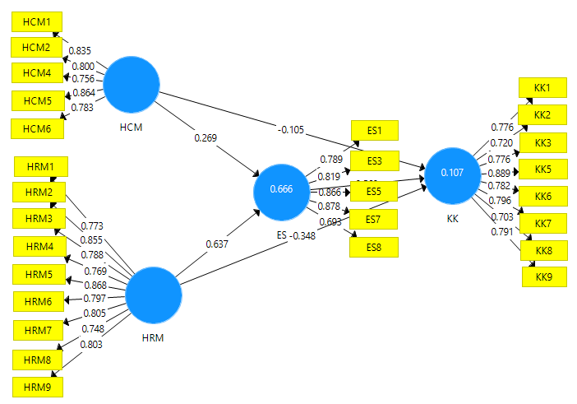The purpose of this test is to determine the validity of the relationship with construct indicators or latent variables. Through testing with Smart PLS 3.0, below is explained each of the loading factors of each variable, as follows:

Figure 1. Loading Factor

Source: Results of questionnaire with Smart PLS 3.0

The picture above explains that some loading factor values below 0.70 have been discarded, so it can be explained as follows:

1. The HCM variable has a loading factor value below 0.70, namely in indicator no: 3,7,8,9.
2. The HRM variable has no loading factor value below 0.70
3. Sharia Economics variable has a loading factor value below 0.70, namely at indicator no: 2,4,6,9
4. Employee Commitment Variable has a loading factor value below 0.70, namely at indicator number: 4.
5. **Average Variance Extracted (AVE) Test**

The purpose of this test is to assess discriminate validity which can be done with average variance extracted (AVE) for each latent variable. The results can be explained in table 1.

**Table 1.** Average Variance Extracted (AVE)

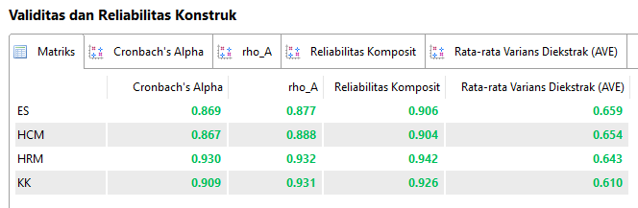

In the table above, it can be seen that the AVE value in each construct is above 0.50, therefore at this test stage it is stated that there are no problems with discriminant validity on these latent variables, or it can be said to have good discriminant validity. The values obtained for AVE are in line with Henseler[26]which suggests that an AVE value greater than 0.50 is acceptable. The correspondence of the authors' AVE values is an indication that the dominant factor from a series of indicators was extracted. As for the composite constraint, the value is well above the 0.70, as suggested by Nunnally in Arasinah.[27]

1. **Discriminant Validity Test**

This test is to ensure that each concept of the latent variables is different from the other variables. The results of the discriminant validity test can be seen in table 2.

**Table 2.** Discriminant Validity Test

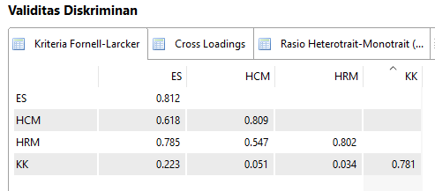

In the table the Islamic Economic Variable of 0.812 means that this value is the root of the AVE value which is greater than the correlation of the HCM variable (0.618), the HRM variable (0.785), the Employee Competence variable (0.223). Meanwhile, the HCM variable has a discriminant value of 0.809, which is greater than the HRM variable (0.547) and the employee commitment variable (0.051) and the discriminant validity value of the HRM variable is 0.802, which is greater than the employee commitment variable (0.034). Thus it can be stated that the latent variable has good discriminant validity.

1. **Composite Reliability Test and Cronbach's Alpha**

The purpose of this test is to determine the reliability of each latent variable. The output results of Smart PLS with Composite Reliability and Cronbach's Alpha are as follows:

**Table 3.** Composite Reliability Test Results and Cronbach's Alpha



From the table above, it is shown that each latent variable has a composite reliability value greater than 0.70, and Cronbach's Alpha is greater than 0.60, meaning that all constructs have good reliability in accordance with the minimum required threshold.

***Inner Model Analysis***

In the analysis of this inner model, the author performs two types of tests, namely: R2 and F2 tests, described as follows:

1. **R Square Analysis**

R Square test to determine the value of determination of the exogenous variable to the endogenous variable. Conditions indicate that the greater the value of determination, the better the variable. The results of the determination test are as follows:

**Table 4.** R Square

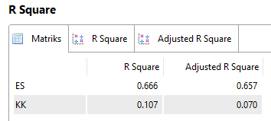

From the table above, it can be concluded that Islamic economic variables contribute 66.6% and the remaining 33.4% by other variables. Likewise, the employee commitment variable contributed 10.7% and the remaining 89.3% by other variables.

1. **F Square Analysis**

The purpose of this F square test is to determine the quality of the latent variable, how big is its significance, it can be seen in the table below:

Table. 5. Test F Square

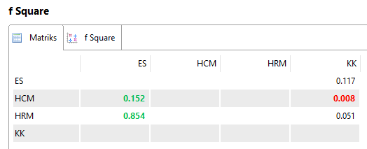

From the table above, it can be explained as follows:

1. Sharia Economics variable has a direct and significant effect on the employee commitment variable of 0.117 because the value is greater than 0.05
2. The HCM variable has no effect on the employee commitment variable indirectly through sharia economics because the value is 0.008, smaller than 0.05. However, the HCM variable has a direct effect on the Islamic Economics Variable of 0.152 > 0.05
3. The variable of human resource development has an indirect effect on employee commitment through sharia economics of 0.051 > 0.05 and has a direct effect on sharia economic variables of 0.854 > 0.05.
4. **Bootstrapping Results**

In the Smart PLS 3.0 test, every effect can be done using the Bootstrapping method on the sample. The purpose of this is to minimize abnormal data in the study. The results of the bootstrapping method using the Smart PLS 3.0 analysis tool are as follows:

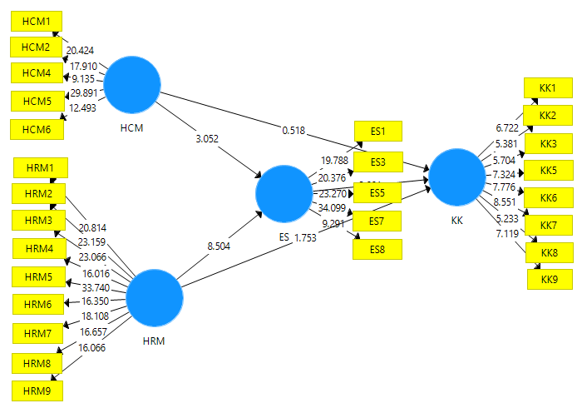

**Figure 2.** Bootstrapping Results

Source: data processed with Smart PLS 3.0

There are two results of the Bootstrapping test, namely the direct effect and the indirect effect. The explanation of the test can be explained in the table as follows:

***Direct Influence***

The results of testing the indirect effect between exogenous variables on endogenous variables can be described in the table below:

**Table 6.** Direct effect

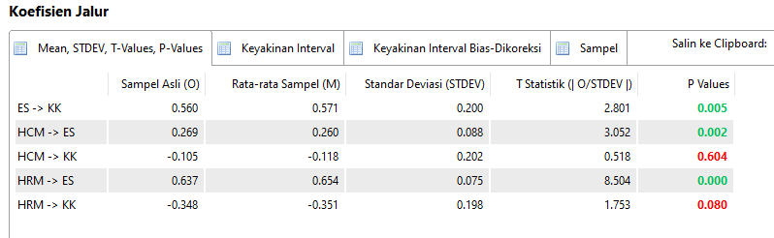

From the picture above, it can be explained that when viewed from the t statistic, it can be concluded as follows:

1. The HCM variable does not directly affect employee commitment by 0.518 because the value is smaller than 1.96, so the null hypothesis is accepted.
2. The HRM variable has a direct effect on employee commitment of 1.755 because the value is greater than 1.96, so the null hypothesis is rejected.
3. The sharia economic variable has a direct effect on employee commitment of 2.801 because the value is greater than 1.96, so the hypothesis is null.

The positive and negative directions can be seen in the original sample (o), and it turns out that there is a negative influence, namely the HCM variable on employee commitment and the resource development variable on employee commitment.

***Indirect Influence***

**Table 7.** Indirect effect

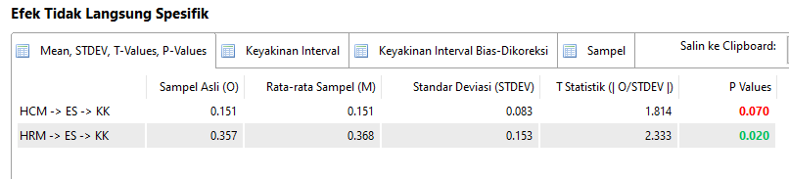

From the picture above, it can be explained that the indirect effect of exogenous variables through mediating variables on endogenous variables can be concluded that the test is carried out through the t statistic or p-value, as follows:

1. The HCM variable does not affect employee commitment indirectly through sharia economics of 1.814 < 1.96
2. The variable of human resource development has an indirect effect on employee commitment through sharia economics by 2,333 > 1.96.

**DISCUSSION**

The results of the author's study between empirical design and previous behavioral research using SEM techniques and using Smart PLS 3.0 as the analysis, there are direct and indirect effects. The focus of this research is to examine the influence of HCM practices and HR development on the achievement of employee commitment in companies in Purwakarta district and the author also evaluates the mediating function of the sharia economy and its effect on employee commitment. Companies in Purwakarta district are facing several dynamic competitive challenges, therefore many companies, especially the garment sector, are out of business. This challenge has not been widely studied by researchers, especially from academia.

The theoretical implications of this research are specifically conveyed, although HCM practices have no direct or indirect effect on employee commitment, but at least HCM practices have slightly applied Islamic economic values, namely human capital.

# CONCLUSION

In conclusion, the findings of this study contribute to the development of human resources, employment, and Islamic economics literature and employee commitment. Some companies should certainly try to improve their HCM practices and Islamic economics in the workplace so that human resource development and employee commitment can be achieved.■

## REFERENCES

Bakir, Muhamadul, Mohd Sofian, Fauzi Hussin, and Khatijah Othman. “Human Capital Development from Islamic Knowledge Management Perspective,” n.d., 9.

Budi Cantika Yuli, Sri, and Nazaruddin Malik. “Nilai Islami pada Proses Rekrutmen Karyawan di Universitas Muhammadiyah Malang.” *JEBA (Journal of Economics and Business Aseanomics)* 4, no. 1 (March 3, 2020). https://doi.org/10.33476/j.e.b.a.v4i1.1239.

Budiarto, Yohanes, and Rani Puspita Wardani. “Peran Keadilan Distributif, Keadilan Prosedural Dan Keadilan Interaksional Perusahaan Terhadap Komitmen Karyawan Pada Perusahaan (Studi Pada PerusahaaN X)” 3, no. 2 (2005): 18.

———. “Peran Keadilan Distributif, Keadilan Prosedural Dan Keadilan Interaksional Perusahaan Terhadap Komitmen Karyawan Pada Perusahaan (Studi Pada Perusahaan X)” 3, no. 2 (2005): 18.

Cupian, Cupian, Muhammad Zaky, Kadar Nurjaman, and Esa Kurnia. “Analisis Pelaksanaan Rekruitmen, Seleksi Dan Penempatan Berdasarkan Perspektif Islamic Human Capital.” *Komitmen: Jurnal Ilmiah Manajemen* 1, no. 1 (April 20, 2020): 50–63. https://doi.org/10.15575/jim.v1i1.8289.

Ekawati, Ratna, and Lilis Karnita Soleha. “Meningkatkan Kemampuan Inovasi Organisasi Melalui Human Capital.” *Jurnal INTEKNA : Informasi Teknik dan Niaga* 17, no. 2 (November 30, 2017): 141–47. https://doi.org/10.31961/intekna.v17i2.479.

Hair, Joseph F., ed. *A Primer on Partial Least Squares Structural Equations Modeling (PLS-SEM)*. Los Angeles: SAGE, 2014.

Hakiki, Kiki Muhammad. “Pemikiran Kalam Syaikh Muhammad Sanusi,” 2011, 16.

Hamadamin, Halbast Hussein, and Tarik Atan. “The Impact of Strategic Human Resource Management Practices on Competitive Advantage Sustainability: The Mediation of Human Capital Development and Employee Commitment.” *Sustainability* 11, no. 20 (October 18, 2019): 5782. https://doi.org/10.3390/su11205782.

H. Hendrianto and Lutfi Elfalahy, “Ayat-Ayat Hukum Dalam Alquran Mengatur Hubungan Sesama Manusia,” *Al-Istinbath : Jurnal Hukum Islam* 6, no. 1 (May 31, 2021): 165, https://doi.org/10.29240/jhi.v6i1.2719.

Hidayah, Siti. “Pengaruh Keadilan Distributif Dan Keadilan Prosedural Terhadap Kinerja Karyawan Bmt Hudatama Semarang,” no. 35 (2013): 15.

Hidayat, Cecep. “Analisis Model Pengukuran Human Capital dalam Organisasi.” *Binus Business Review* 4, no. 2 (November 29, 2013): 879–85. https://doi.org/10.21512/bbr.v4i2.1403.

———. “Analisis Model Pengukuran Human Capital dalam Organisasi.” *Binus Business Review* 4, no. 2 (November 29, 2013): 879–85. https://doi.org/10.21512/bbr.v4i2.1403.

Islam, Dakwah Ilal. “Pengantar Sistem Ekonomi Islam,” n.d., 702.

Islam, Gazi. “Recognition, Reification, and Practices of Forgetting: Ethical Implications of Human Resource Management.” *Journal of Business Ethics* 111, no. 1 (November 2012): 37–48. https://doi.org/10.1007/s10551-012-1433-0.

J, Henseler, Hubona G, and Ray P.A. “Using PLS Path Modeling in New Technology Research: Updated Guidelines,” 2016.

Jatmiko, Wahyu, and Nur Hajrina. “Between Sharia Maqasid Index and Human Development Index: Which One Is Happier?” *SSRN Electronic Journal*, 2015. https://doi.org/10.2139/ssrn.2889247.

Kamis, Arasinah, and Ramdzan Ali Saibon. “The SmartPLS Analyzes Approach in Validity and Reliability of Graduate Marketability Instrument,” 2020.

Khan, Dr Muhammad Tariq. “Development of Human Capital Through Institution of Islamic Waqf” 7 (2015): 15.

Klinken, Gerry van, and Ward Berenschot. *In search of Middle Indonesia: kelas menengah di kota-kota menengah*, 2016.

Kurniati, Anna, and Ferry Efendi. *Kajian Sumber Daya Manusia Kesehatan di Indonesia*. Salemba Medika, 2012. https://doi.org/10.13140/RG.2.1.1440.6804.

Minto Waluyo. “Buku Sem.Pdf,” n.d. Penerbit: UPN :Veteran” Jatim. ISSBN: 978-6029-372960

Posthuma, Richard A., Michael C. Campion, Malika Masimova, and Michael A. Campion. “A High Performance Work Practices Taxonomy: Integrating the Literature and Directing Future Research.” *Journal of Management* 39, no. 5 (July 2013): 1184–1220. https://doi.org/10.1177/0149206313478184.

Pradeep, Roshini, Aqsa Akram, Matthew C Proute, Nageshwar R Kothur, Petros Georgiou, Tatsiana Serhiyenia, Wangpan Shi, Mina E Kerolos, and Jihan A Mostafa. “Understanding the Genetic and Molecular Basis of Familial Hypertrophic Cardiomyopathy and the Current Trends in Gene Therapy for Its Management.” *Cureus*, August 29, 2021. https://doi.org/10.7759/cureus.17548.

Sarwono, Jonathan. “Mengenal Path Analysis: Sejarah, Pengertian Dan Aplikasi” 11, no. 2 (n.d.): 12.

Yuliani, Febri. “Kebijakan Restrukturisasi Organisasi Dan Pemberdayaan Sumber Daya Manusia,” n.d., 6.

1. Wahyu Jatmiko and Nur Hajrina, “*Between Sharia Maqasid Index and Human Development Index: Which One Is Happier*?,” *SSRN Electronic Journal*, 2015, https://doi.org/10.2139/ssrn.2889247.
2. CupianCupian et al., “Analisis Pelaksanaan Rekruitmen, Seleksi Dan Penempatan Berdasarkan Perspektif Islamic Human CapitaL,” *Komitmen: Jurnal Ilmiah Manajemen* 1, no. 1 (April 20, 2020): 50–63, https://doi.org/10.15575/jim.v1i1.8289.
3. Sri Budi Cantika Yuli and Nazaruddin Malik, “Nilai Islami pada Proses Rekrutmen Karyawan di Universitas Muhammadiyah Malang,” *JEBA (Journal of Economics and Business Aseanomics)* 4, no. 1 (March 3, 2020), https://doi.org/10.33476/j.e.b.a.v4i1.1239.
4. jonathan Sarwono, “Mengenal Path Analysis: Sejarah, Pengertian Dan Aplikasi” 11, no. 2 (n.d.): 12.
5. Gerry van Klinken and Ward Berenschot, *In search of Middle Indonesia: kelas menengah di kota-kota menengah*, 2016.
6. Minto Waluyo. “Buku Sem.Pdf,” n.d. Penerbit: UPN :Veteran” Jatim. ISSBN: 978-6029-372960
7. MuhamadulBakir et al., “Human Capital Development from Islamic Knowledge Management Perspective,” n.d., 9.
8. Febri Yuliani, “Kebijakan Restrukturisasi Organisasi Dan Pemberdayaan Sumber Daya Manusia,” n.d., 6.
9. Dr Muhammad Tariq Khan, “Development of Human Capital Through Institution of Islamic Waqf” 7 (2015): 15.
10. kiki Muhammad Hakiki, “Pemikiran Kalam Syaikh Muhammad SanusI,” 2011, 16.
11. Bakir et al., “Human Capital Development from Islamic Knowledge Management Perspective.”
12. Cecep Hidayat, “Analisis Model Pengukuran Human Capital dalam Organisasi,” *Binus Business Review* 4, no. 2 (November 29, 2013): 879–85, https://doi.org/10.21512/bbr.v4i2.1403.
13. Anna Kurniati and Ferry Efendi, *Kajian Sumber Daya Manusia Kesehatan di Indonesia* (Salemba Medika, 2012), https://doi.org/10.13140/RG.2.1.1440.6804.
14. Yohanes Budiarto And Rani PuspitaWardani, “Peran Keadilan Distributif, Keadilan Prosedural Dan Keadilan Interaksional Perusahaan Terhadap Komitmen Karyawan Pada Perusahaan (Studi Pada Perusahaan X)” 3, No. 2 (2005): 18.
15. siti Hidayah, “Pengaruh Keadilan Distributif Dan Keadilan Prosedural Terhadap Kinerja Karyawan BmtHudatama Semarang,” no. 35 (2013): 15.
16. Richard A. Posthuma et al., “A High Performance Work Practices Taxonomy: Integrating the Literature and Directing Future Research,” *Journal of Management* 39, no. 5 (July 2013): 1184–1220, https://doi.org/10.1177/0149206313478184.
17. *Roshini Pradeep et al., “Understanding the Genetic and Molecular Basis of Familial Hypertrophic Cardiomyopathy and the Current Trends in Gene Therapy for Its Management*,” *Cureus*, August 29, 2021, https://doi.org/10.7759/cureus.17548.
18. H. Hendrianto and Lutfi Elfalahy, “Ayat-Ayat Hukum Dalam Alquran Mengatur Hubungan Sesama Manusia,” *Al-Istinbath : Jurnal Hukum Islam* 6, no. 1 (May 31, 2021): 165, https://doi.org/10.29240/jhi.v6i1.2719.
19. Dakwah Ilal Islam, “Pengantar Sistem Ekonomi Islam,” n.d., 702.
20. Joseph F. Hair, ed., *A Primer on Partial Least Squares Structural Equations Modeling (PLS-SEM)* (Los Angeles: SAGE, 2014).
21. Gazi Islam, “Recognition, Reification, and Practices of Forgetting: Ethical Implications of Human Resource Management,” *Journal of Business Ethics* 111, no. 1 (November 2012): 37–48, https://doi.org/10.1007/s10551-012-1433-0.
22. Ratna Ekawati and LilisKarnitaSoleha, “Meningkatkan Kemampuan Inovasi Organisasi Melalui Human Capital,” *Jurnal INTEKNA : Informasi Teknik dan Niaga* 17, no. 2 (November 30, 2017): 141–47, https://doi.org/10.31961/intekna.v17i2.479.
23. Bakir et al., “Human Capital Development from Islamic Knowledge Management Perspective.”
24. Yohanes Budiarto and Rani PuspitaWardani, “Peran Keadilan Distributif, Keadilan Prosedural Dan Keadilan Interaksional Perusahaan Terhadap Komitmen Karyawan Pada Perusahaan (Studi Pada Perusahaan X)” 3, no. 2 (2005): 18.
25. Hair, *A Primer on Partial Least Squares Structural Equations Modeling (PLS-SEM)*.
26. Henseler J, Hubona G, and Ray P.A, “Using PLS Path Modeling in New Technology Research: Updated Guidelines,” 2016.
27. Arasinah Kamis and Ramdzan Ali Saibon, “The SmartPLS Analyzes Approach in Validity and Reliability of Graduate Marketability Instrument,” 2020.